Maryon Parks Management Plan 2010

Including Maryon Park, Maryon Wilson Park, Gilberts Pit and Barrier Park

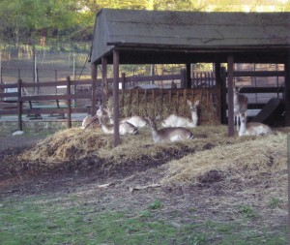
The Deer Pen at Maryon Wilson Park

Contents

PART I: WHERE ARE WE NOW? 3
INTRODUCTION 3
What is a Park Management Plan 3
What is the purpose of this management Plan 4
SITE DESCRIPTION AND INFORMATION BASE 5
Brief Site Description 5
Greenwich Policies relating to the parks 8
Gilberts Pit. SSSI landscape and management issues 8
Topography and landscapes 10
Paths and Access to the parks 14
Park Furniture, Facilities and Infrastructure 14
Main Park Uses and Users 17
Current Management Arrangements 18
PART II: WHERE DO WE WANT TO GET TO? 20
VISION 20
ANALYSIS AND ASSESSMENT 20
Gilberts Pit SSSI 21
Maryon Park 22
Maryon-Wilson Park 22
Barrier Park 23
STRENGTHS 23
CHALLENGES 23
RECOMMENDATIONS 24
Overall recommendations 24
Gilberts Pit 24
Maryon Park 24
Maryon-Wilson Park 24
Barrier Park 24
PART III: HOW WILL WE GET THERE? 25
ACTION PLAN 25
PART IV: HOW WILL WE KNOW WHEN WE’VE ARRIVED 29
MONITORING AND REVIEW 29
APPENDIX I: History of the parks 30
Historic context for Charlton Estate 30
Maryon-Wilson Park History 30
Maryon Park History 32
Gilbert’s Pit History 34
APPENDIX II: Gilberts Pit PDO’s 36
APPENDIX III: Demographic Context 37
APPENDIX IV: Extracts from 1997 plan 38
APPENDIX V: Policies and legislation……………………………………………………………………58

Please note that all maps and diagrams contained within this document have been derived from the Greenwich Council GIS system and are subject to copyright restrictions

PART I: WHERE ARE WE NOW?

INTRODUCTION

What is a Park Management Plan

Management Plans are an important aid to the efficient and effective management of any site. A Management Plan forms part of a process for evaluating performance, consulting and involving people, strategic planning and providing continuity. Individual plans will be specific to each park and will deliver aims and objectives specific to the needs of the local community who will be directly involved in its formulation.

A Park Management Plan also provides an excellent opportunity to collate a wealth of information relating to the park that the management authority possesses, into a single comprehensive document.

If you require any further details about this plan please contact:

Address: Parks & Open Spaces
Shooters Hill Depot
Shooters Hill
Opposite Eaglesfield Rd
London
SE18 3HP

Tel. 020 8856 2232
Email parks@greenwich.gov.uk

This park is allocated a technical officer who can be contacted for any further information (using the contact details provided above).

There is an active Friends of Group for Maryon Parks and contact details can be found on their web site at www.friendsofmaryonparks.org

What is the purpose of this management plan

As well as developing a Green Space Strategy, the production of individual management plans for each park is good practice and one of the action points from the Green Space Strategy.

The Maryon Parks Management Plan will be fully reviewed and updated in 2015 by Parks & Open Spaces Management team

It is expected that the plan will provide a framework within which any future decisions concerning this site will be taken and that the rolling reviews will inform future strategic and management planning. In addition, it is hoped that the management plan will assist with allocating existing and securing additional resources for developments on this site that this management plan specifies.

Future actions / priorities for this site are identified in the action plan within this document. This management plan therefore provides a benchmark against which future progress can be measured.

SITE DESCRIPTION AND INFORMATION BASE

Brief Site Description

Maryon Wilson Park, Maryon Park, Gilberts Pit and Barrier Park are located in the Woolwich Riverside Ward and the Charlton Ward of the London Borough of Greenwich.

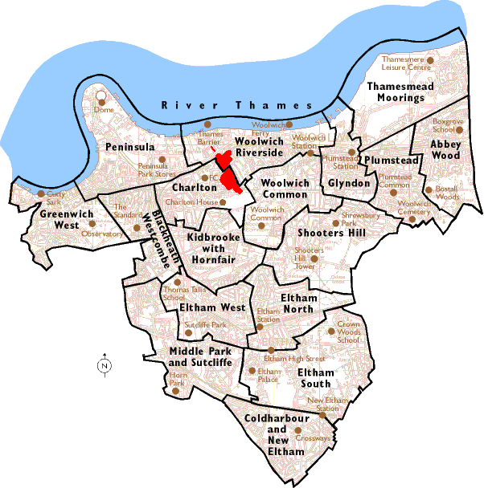
Location of the parks in the London Borough of Greenwich

Maryon Wilson Park, Maryon Park, Gilberts Pit and Barrier Park were at one stage all part of the Maryon-Wilson estate (see Appendix I), along with Charlton and Hornfair Parks. The Maryon- Wilson’s were once the Lords of the Manor of Charlton and their family house was located in Charlton Park (now known as Charlton House)

Maryon Wilson Park, Gilberts Pit, Maryon Park and Barrier Park are all owned by Greenwich Council, and are maintained by the Greenwich Council’s Parks and Open Spaces Department.

The parks occupy the following areas:-
Maryon Wilson Park – approximately 12.5 ha
Gilberts Pit – approximately 4.8 hectares
Maryon Park – approximately 7.5 hectares
Barrier Park – approximately 0.6 hectares

The parks detailed in this plan are of very varied character, and contain a number of very significant features of interest to the wider public.

- Gilberts Pit is listed as a Site of Special Scientific Interest (SSSI) for its unique geology. It is the only location where the entire stratigraphy, consistent with most of London’s underlying geology, is displayed at one site.

- Gilberts Pit contains a small remnant of a Roman encampment on The Ridge. Unfortunately now mostly destroyed through the excavation of quarries at its location.

- Maryon Wilson Park contains a fenced animal park that is operated for the local community and beyond to have some exposure to farm animals.

- The Green Chain Walk, the Capital Ring Walk and the Charlton Loop Walk all run through the parks.

- Maryon Park was a set location for the 1966 cult film Blow Up by Michelangelo Antonioni.

The parks are surrounded by mainly residential roads, with the exception of the road separating Gilberts Pit and Maryon Park from Barrier Park, that being the A206 Woolwich Road.

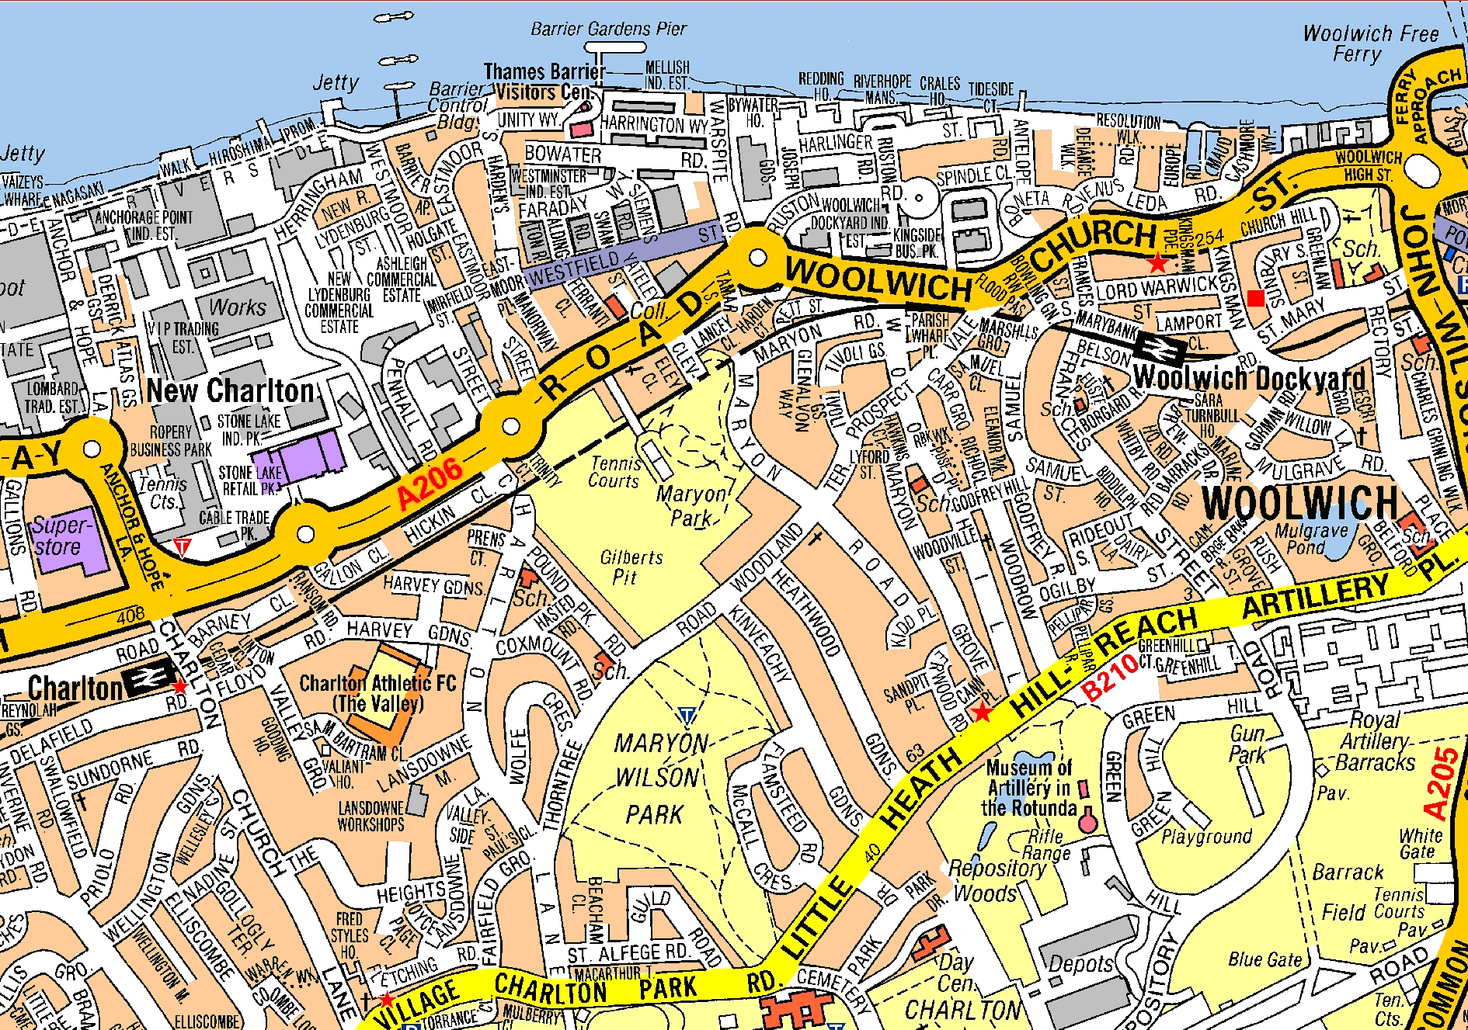
The parks and their immediate surroundings

The parks are of varied slope and aspect, and their geology is very varied, as can be seen by the following diagram.

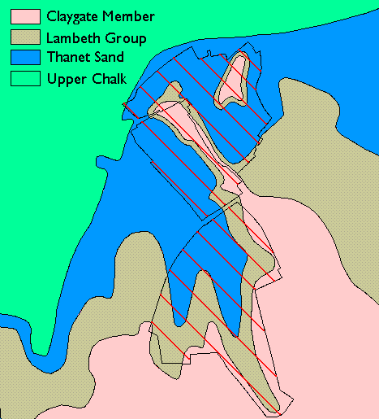
Geology of the parks

As Gilberts Pit is designated as an SSSI site, previous plans and management statements have been written for Gilberts Pit including the 1997 Management Plan by London Conservation Services (agreed by English Nature) and Natural England’s Site Management Statement of 2001. A management Plan was written for Maryon Wilson Park by Jeremy Shearmur (Greenwich Council) in 2000. This plan will incorporate elements from those documents, updating as necessary.

Maryon Park and Gilberts Pit are on a single large piece of land, most of which was the site of two large aggregate pits. The method of landscape formation and consequent re-use has resulted in two adjoining parks of very different character that are separated by a steep ridge.

Most of the area covered by the four parks was once entirely covered by what was known as the ‘Hanging Wood’. This was an area frequented by highwaymen and so named as it was the place where a number were executed for this crime.

Today the main fragments of the Hanging Wood are in Maryon Wilson Park. As a result, Maryon Wilson Park and Gilberts Pit are both classified as ‘natural / semi-natural open space’ by the Greenwich Council Green Space Strategy. Maryon Park is classified as a ‘Local Park’ and Barrier Park is classified as ‘Other’.
Barrier Park, Gilberts Pit and Maryon Wilson Park are open 365 days a year, while Maryon Park is a gated park, open daily times slightly varying according to season. There are no leases affecting the public part of the parks.

Greenwich Policies relating to the parks

The main document which sets out local policies which directly affect the management of the parks within this document is the Greenwich UDP (2006 adopted version). The parks are designated under the following UDP policies and explained in more detail in Appendix V
- Metropolitan Open Land
- Green Chain
- Site of Nature Conservation Importance (SNCI, or SINC)
- Area of special character of Metropolitan Importance
- Green Chain Walk
- Thames Waterfront Zone (Maryon Park Northern extension and Barrier Park only)

Gilberts Pit SSSI landscape and management issues

Geology and SSSI
As mentioned, Gilberts Pit was designated as a Site of Special Scientific Interest for its Geological Heritage. A copy of the notification and several other relevant documents can be found by accessing http://www.english-nature.org.uk/Special/sssi/search.cfm and searching for Gilberts Pit.

The main reason for the SSSI designation is the presence of the cliff that runs along the boundary between Maryon Park and Gilberts Pit. Its exposed faces exhibit one of the most complete sequences of lower Tertiary, Paleocene rocks and sediment in Great Britain, including the type section of the Woolwich Beds.
Exposed in the south-east face of the pit are the Blackheath, Woolwich and Thanet Beds deposited approximately 50-55 million years ago. These conformably overlie the now concealed Cretaceous Chalk. The north-east pit face, which is now degraded and overgrown, provides additional but more limited exposure of the Blackheath and Woolwich Beds.

The sequence of sands and clays exposed in Gilberts Pit has been the subject of much scientific research over many years, providing vital information about the environment, climate and geography which prevailed in Southern England during the lower Tertiary period, around 65 million years ago.

The ridge itself was created through the quarrying of sand and gravel on either side. The eastern pit (Maryon Park) was the first to be quarried, with work commencing sometime in the early 17th century. Work started in the western pit (Gilberts Pit) in 1867. In 1870, all quarrying operations were moved to the western pit (Gilberts Pit). The quarries were historically known as the Charlton Sandpits. Further historic details can be found in Appendix I.

The current level of the floor of both pits is around 5 metres above the deepest level to which the quarries were originally dug, Maryon Park having been landscaped by the London County Council in 1893 and Gilberts pit being used as a site to dump bomb damaged rubble after the Second World War.

At the northern end of the ridge, a lookout has been provided, which has spectacular views over the Thames barrier through to Canary Wharf.

The sides of the pit have been traditionally used by local youths as a large ‘toboggan slide’. Usually they find a flat object (roofing iron/real estate signs/fencing etc) and use it as a sledge.

There is a positive consequence of this usage; where the “tobogganing” occurs, the vegetation is kept from growing, which means that vegetative control measures are not necessary.
The negative consequences of this usage however are;
- Accelerated erosion of the upper pit face, particularly the Blackheath layer
- Eroded talus being deposited at the bottom of the slope, obscuring the lower geological layers from sight
- Littering (the makeshift sledges are rarely removed from the site)

A palisade fence was installed around the ridge by Natural England in 1997, in an attempt to prevent further erosion occurring.

Ecology
As already mentioned, Gilberts Pit may contain remnants of the ancient Hanging Wood. Since the pit was used as a bomb damage dumping ground during the Second World War, the woodland has regenerated and spread into the pit area. The site is now dominated by secondary woodland and scrub, with only fragments of acid and neutral grassland surviving. Acid grasslands are declining in condition and frequency across the London area and should be considered a priority habitat. In Gilberts Pit, the woodlands and scrub have been gradually encroaching onto the grassland.

The 1997 plan dealt with these issues in some detail and has not lost its relevance. A large part of the 1997 management plan is included in Appendix IV with some updates.

Topography and landscapes

Maryon Park including Gilberts Pit
There are two distinct sections of Maryon Park, each of which are of quite distinct character; the northern half and the southern half. These two halves are separated by a railway cutting which is part of the North Kent Line currently operated by South-eastern Railways. The line runs through tunnels underneath both Gilberts Pit and Maryon Park and is only visible in the cutting in Maryon Park.

Landscaped Areas
The northern section of the park (directly adjacent to the Woolwich Road), was only transformed into a public park after widening of the A206 Woolwich Road in 1996. During the course of this project, the houses and land adjacent to this section of the road were acquired under compulsory acquisition, demolished and the land re-integrated into the road with the remainder transformed into a landscaped open space that was handed over to Greenwich Council.

The southern section of the park was landscaped around 1908 when the park was purchased by the LCC. The initial landscaping included the tennis courts, the children’s open air gymnasium (the very first of its type) and the planting out of Cox’s Mount, the large mound in the north east corner of the park. A bandstand was also erected as part of the initial landscaping, but this became derelict and was removed in the 1970’s.

In the north-west corner of the park is a large mound known as Cox’s Mount, the sides of which are planted out with poplars and many other native species. The top of Cox’s Mount is maintained as amenity grass.

Natural Areas
The Natural areas within Maryon Park are mainly restricted to the steep slopes that make up the ridge between Maryon Park and Gilberts Pit and the area behind the railway cutting. The area that makes up the ridge between the two parks is part of the Gilberts Pit SSSI and has been fenced with 2 meter Palisade fencing by English Nature.

The northern extension has a number of features, including an area that is managed as wild flower meadow and the garden beds, which are planted out with native species.

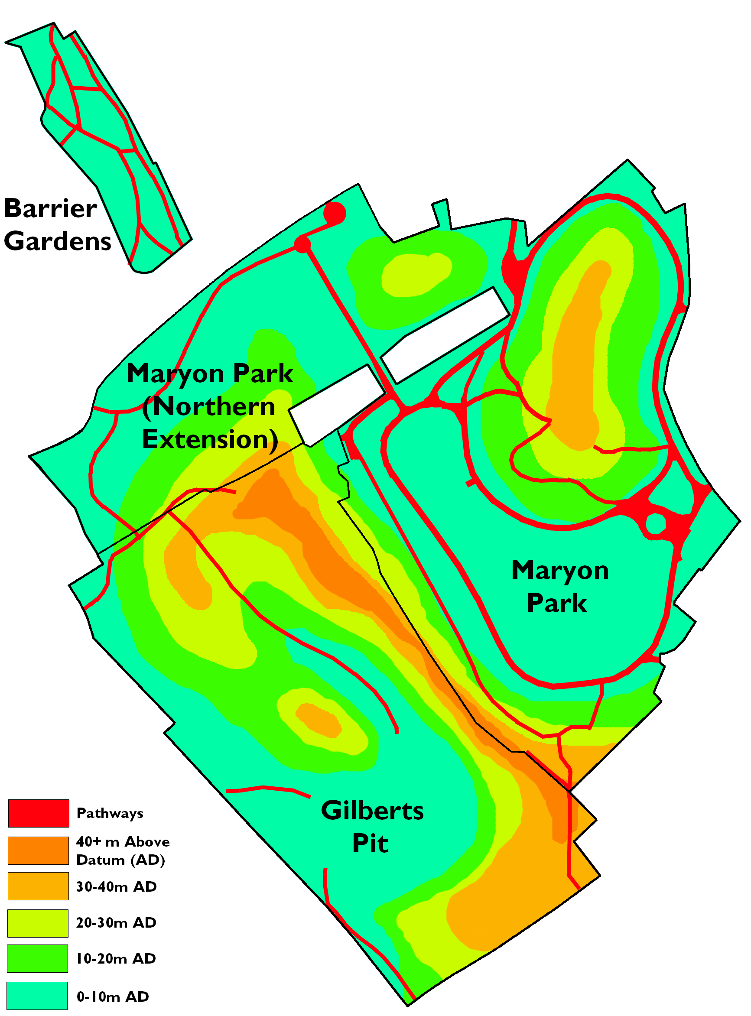
Estimated topography of Maryon Park and Gilberts Pit (also showing Barrier Park)

Barrier Park
Barrier Gardens consists of a flat linear north-south block of land that was at one stage occupied by the Siemens Brothers Telegraph Works. (Factory opened in 1863, closed in 1968)
Greenwich Council identified the land as derelict in the mid-eighties and sought funding from the GLC to acquire and re-landscape it. Funding was secured and Mike Tanton of Greenwich Council designed the landscaping in keeping with the new landscaping in Maryon Park.

The landscaping within Barrier Gardens consists of beds planted with native trees and shrubs and amenity grassed areas.

Maryon Wilson Park
Maryon Wilson Park can be broken down into two separate areas, the wooded area and the amenity grassed area which includes the animal enclosures.
There is a small watercourse that originates in Maryon Wilson Park, as can be seen in the map on the next page.

Maryon Wilson Park varies in height from 12 to 42 metres above datum.

Wooded Area
The wooded area in Maryon Wilson Park is mainly in the southern half of the park. This area of the park is the head of a creek that runs through the park and down to the Thames and as a consequence, this part of the park has formed a steep valley which only flattens out in the amenity area of the park.

The woodland in this area is rather diverse, as the Maryon Wilson family planted quite a number of non-native species in this part of the park, including a variety of conifers.

There are no buildings in the wooded area of Maryon Wilson Park.

Amenity grassed area
The amenity grassed area in Maryon Wilson Park is in the northern half of the park and is scattered with many mature trees of a variety of species.

This part of the park contains three large open fenced off areas and several small buildings which are operated as animal enclosures. The northern enclosure contains a herd of deer, the ancestors of which were donated to the Greenwich Council by Sir Spencer Maryon-Wilson.

Animal Enclosures
Within Maryon Wilson Park are three large open fenced areas which, in addition to a small animal house in the south-east corner of the park, containing a range of animals, including deer, sheep, ponies, pigs, goats, rabbits, chinchillas, terrapins, guinea pigs, geese, chickens, guinea fowl, mice, rats, peacocks and a cat. At the time of writing, the ponies from the Charlton Park Riding For the Disabled Group are housed within one of the enclosures.

The fencing around two of the three enclosures was refurbished in 2006.

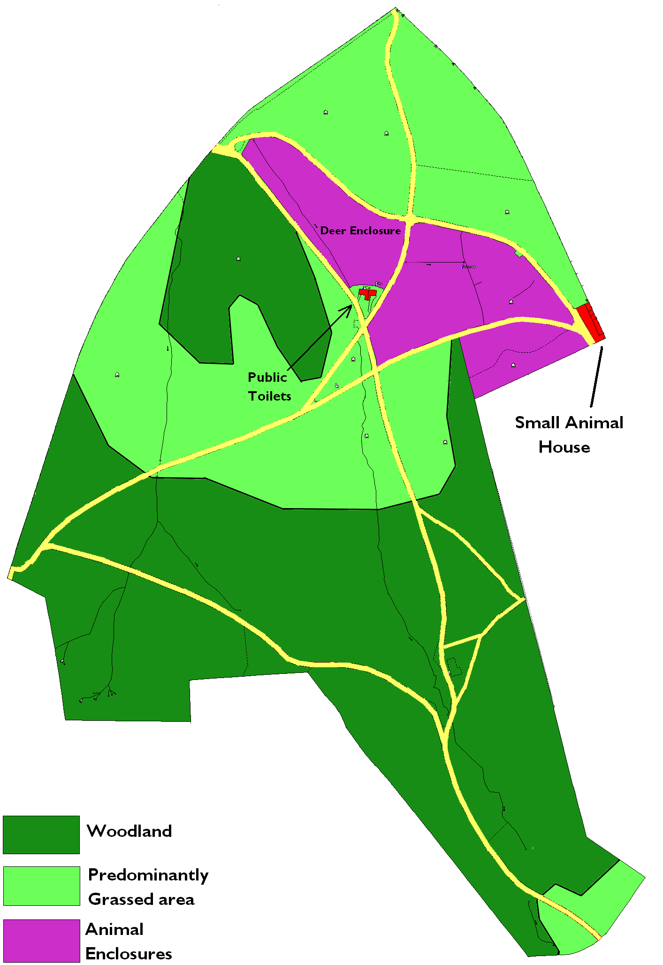
Maryon Wilson Park
Paths and Access to the Parks

As mentioned, the Green Chain Walk, the Capital Ring and the Charlton Loop walks all run through the parks. The Capital Ring and the Green Chain walk are considered as being strategic routes by the Mayor of London’s Transport Strategy.

Gilbert’s Pit
Gilbert’s Pit has entrances onto Thorntree Road to the south-east and a vehicle gate and pedestrian access via Pound Park Road to the west. It is also accessible to pedestrians through the Maryon Park northern extension.
The pathways within the park are all surfaced with loose gravel, or merely consist of desire lines worn into the meadow grass. The entrances are not disabled accessible as there have been problems with motorbike associated anti-social behaviour on the site. All the entrances have large traffic control gates to prevent wheeled access. Access to the North is very steep, often stepped and is inherently not amenable to wheelchair use. As a result of both the nature of the park itself and the control measures to stop motorbike anti-social behaviour, there is currently no access at all for wheelchair users.

Maryon Park
Maryon Park has entrances from Thorntree Road, the Woolwich Road (A206) and Maryon Road.
The majority of the park is accessible by wheelchair, with the exceptions of the pathways that climb up the walls of the pit, as they have a large number of steps. All the pathways within the park are paved with either concrete or bitumen.

Maryon Wilson Park
Maryon Wilson Park is accessible via an entrance off Charlton Park Road, McCall Crescent and two entrances off Thorntree Road. The major pathways through the park are bitumenised with minor pathways being paved with loose gravel, but many of the pathways are not DDA compliant as many of the sloping pathways are over a 1 in 14 gradient.

Barrier Park
Barrier Park is not fenced or gated where the park adjoins roads. All of the pathways within it are bitumenised and the whole park is of a gradient less than 1 in 14, which means that the whole park is very wheelchair accessible.

Park Furniture, Facilities and Infrastructure

Maryon Wilson Park

Furniture and Signage
Maryon Wilson Park contains interpretational signs at the northern and southern entrances, with directional signs at major path intersections. In addition, there are wooden posts showing the direction of the Green Chain Walk, the Capital Ring and the Charlton Loop at strategic locations.
All the signage described above has been installed by the Green Chain Organisation.

Maryon Park also contains a variety of litter bins, dog bins and seating, all located at strategic locations within the park.

Animal Enclosures
Maryon Wilson Park contains three large animal enclosures which contain a variety of animals. The original impetus for the animal enclosure was provided when the park was first opened to the public. Sir Spencer Maryon-Wilson presented a herd of deer to the council, which were intended to be symbolic of the original use of the forested estate at one time used as a hunting park.
Currently, one of the pens is used for deer, one for ponies, pigs and domestic fowl and the other is used for goats (the fencing around the goat pen requires refurbishment). The ponies belong to the Charlton Park Riding for the Disabled group, who currently keep their ponies in the enclosure.
The animal enclosures are run as an animal education collection along with the small animal house.

Small animal house and staff rest room
Adjacent to the animal enclosures, next to the Flamsteed Road entrance is a small enclosure containing two buildings, one of which is used as a small animal house for keeping small mammals and birds and where the Park Rangers run animal education programme for school children and other visitors. The other building is being used as a mess room by parks staff. Children wash their hands after attending animal education sessions in a nearby portable unit.

Toilet block
Currently, there is a public derelict and amenities building directly to the west of the animal enclosures. At the time of writing, the toilets are not operational and are closed to the public.

Gilberts Pit

Furniture and Signage
Furniture and Signage within Gilberts Pit includes the Green Chain directional posts and signage which has been installed by the Green Chain Organisation, fences and gates to reduce motorcycle usage within the park, the palisade fence installed by English Nature to protect the SSSI site and the seat at the lookout. There is also an interpretational sign at the foot of an exposed section of the ridge indicating the various geological strata.

Maryon Park

Furniture and Signage
Maryon Park contains a variety of seats, litter bins, dog bins and signs. The signs within the park are mostly Green Chain directional signage and interpretational signs, with the playground containing a sign indicating the recommended age range of the playground. They also advise on the policy of no dogs in playgrounds and emergency numbers.

Playground, Ball Court and Picnic Area
Just north of the railway cutting is the ball court. The ball court is paved with tarmac and is fenced with a 3 meter palisade fence. Directly adjacent to the south of the ball court is the playground.
The playground was first installed by Sir Spencer Maryon-Wilson in 1895 and was the first outdoor gymnasium of its type in London. The play equipment conforms to the Euorpean Union Standard EN1176 and EN1177. Visual Inspections are carried out on a regular basis, with a more detailed inspection on a bi-monthly basis and an independent inspection on an annual basis.

Keepers Lodge and toilets
The Keeper’s Lodge is directly adjacent to Maryon Road and a public amenity block is built on the western side of it. The lodge and amenity block were built in 1896. In the past there were several other buildings within Maryon Park, including a Café building and a Victorian bandstand. The Café was removed in 2002. The bandstand was removed in the 1970’s.
Map showing different areas within Maryon Park and Gilberts Pit.

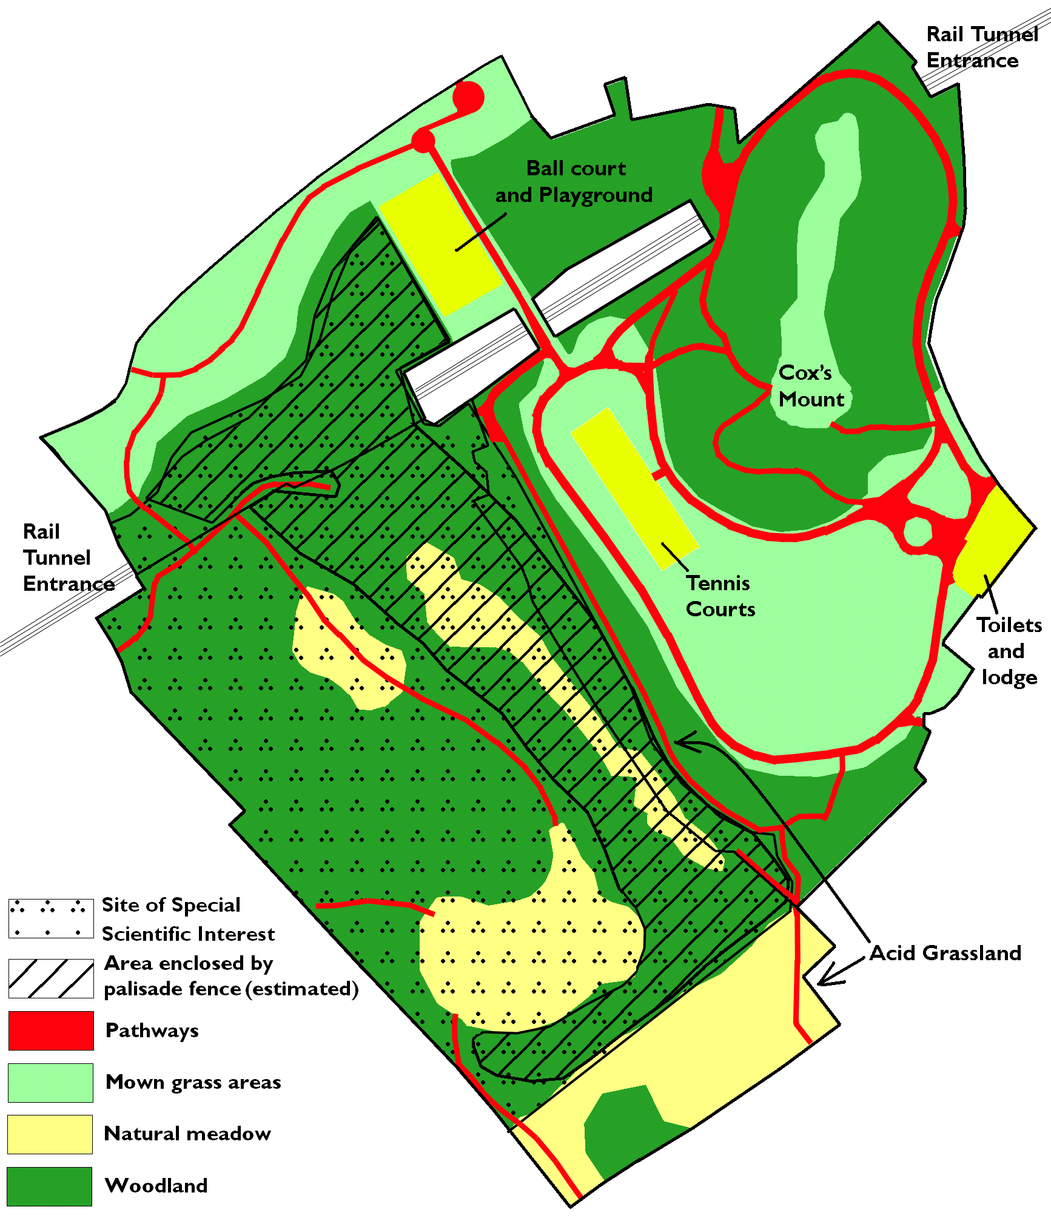

Main Park Uses and Users

Currently, the main users of the parks are all from the local area and mainly use the parks for casual recreation / dog walking or as a through route. Notable exceptions are the Maryon Wilson Park Animal collection and Gilbert’s Pit. The animal collection can, at times, attract significant numbers of users from anywhere within the M25. Gilberts Pit is an excellent attraction for members of the scientific and engineering community who wish to study the geology of the London area but this does not happen on a regular basis.

Demographics of the Charlton Ward and Woolwich Riverside Ward
The demographic information contained in this section is gathered from the 2001Census Information as summarised on the Greenwich web site, under 2001Census Ward Profiles. The information relates to Charlton Ward and Woolwich Riverside Ward as a whole and not specifically to the area surrounding Maryon Parks.

Charlton Ward
The resident population of Charlton ward as measured in the 2001 census was 12,608. This is made up of 5,944 males (47%) and 6,664 (53%) females.

Ethnicity in Charlton was 75.2% White, 12.3 % Black or Black British, 6.3% Asian or Asian British, 3.6% were mixed and 2.5% was Chinese or another ethnic group.

The 2001 census indicated that the majority of people, 35% were in the 25 – 44 age bracket, followed by 19.4% in the 45 – 64 age bracket and 13.5% are in the 5 – 15 age bracket. The average age of a resident in the Charlton Ward is 36.

56.9% of the 16 – 74 population were economically active (full time, part time and self employed)

44.3% of the ward had no access to cars or vans and 43.2% had access to one car or van.

Woolwich Riverside Ward
The resident population of Woolwich Riverside ward as measured in the 2001 census was 12,767. This is made up of 6,176 males (48%) and 6,591 (52%) females.

Ethnicity in Woolwich Riverside was 64.4% White, 21.6 % Black or Black British, 5.6% Asian or Asian British, 3.8% were mixed and 4.7% was Chinese or another ethnic group.

The 2001 census indicated that the majority of people, 34.9% were in the 25 – 44 age bracket, followed by 16.3% in the 45 – 64 age bracket and 16.2% are in the 5 – 15 age bracket. The average age of a resident in the Woolwich Riverside Ward is 32.

49.1% of the 16 – 74 population were economically active (full time, part time and self employed).

54.8% of the ward had no access to cars or vans and 36.5% had access to one car or van.

Stakeholders
Greenwich Council
- Directorate of Culture & Community Services (P&OS, Sports Promotion, Libraries & Museum Services, Charlton House Management)
- Directorate of Regeneration, Enterprise and Skills (Property Services, Planning Control)
- Chief Executives Department (Communications / Community Engagement)
- Neighbourhood Services (Neighbourhood Panels/Representatives)
- Children’s Services
- Charlton Park School

Community
- Friends of Maryon & Maryon Wilson Parks
- Charlton Society
- Riding School for Charlton Park School

Agencies
- Police, Fire & Rescue Service
- Green Chain Walk

Business
- Businesses in local shopping parade (Charlton Village)

Politicians
- Ward Members (Charlton)
- MP

Current Management Arrangements

Management Structure
The management of the parks described in this plan is the responsibility of the Parks & Open Spaces Department within Greenwich Council. The Parks and Open Spaces Department is located within the Directorate of Culture and Community Services. The Parks and Open Spaces Senior Management Team is accountable for the overall management responsibility of the Service.
Individual management functions are devolved and key functions are identified as follows:
- Horticultural Maintenance
- Park Keepers, Rangers and Parks Security
- Parks Development
- Fixed Equipment Playgrounds
- Ecology & conservation
- Tree & Woodland maintenance
- Administration – Sports lettings, complaints monitoring

Staff Presence
Grounds maintenance in Greenwich Council’s parks is provided by the Council’s own workforce. The District Manager responsible for the grounds maintenance staff initially inspects standards.

A further check is carried out by a Quality Control Officer, who is centrally based staff, reporting to the Assistant Technical Manager. Senior management also carry out random checks.

The Council’s horticultural grounds maintenance in most cases is carried out by a number of “mobile teams”, which are allocated a group of parks. The number of staff comprising each mobile team can vary at any time, depending on workload. Individual supervisors have the discretion to transfer staff and equipment between mobile teams according to anticipated and actual workload.

Park Keepers perform a range of duties: - to ensure the safety of the public visiting the park, provide assistance where appropriate, daily visual inspection of playgrounds, opening and closing of gates & facilities, and maintain the park free of litter.

Sustainability
The Greenwich Council Parks and Open Spaces section have an environmental management system (EMS) which is externally audited by the British Standards Institute and certified against the internationally respected ISO 14001 environmental standard series.

Recycling
The Parks and Open Spaces department recycle as much of its green waste as possible. All green waste is taken to Holbrook Meadow and shredded on site. The resulting mulch is reused throughout Greenwich’s parks.

Small wood is chipped and large wood is sometimes left on site to create wood piles to encourage increased bio-diversity and potential habitats for stag beetles and other invertebrates.

Marketing
Information about local parks within the borough can be found on the Greenwich Council website www.greenwich.gov.uk

PART II: WHERE DO WE WANT TO GET TO?

VISION

The plan aims to aid the efficient and effective management of the site to create a safe, clean and enjoyable experience for the local community and visitors and help to achieve the Council’s strategic intentions for the green space strategy by developing a vibrant and sustainable park.

General Objectives

- To reduce Anti Social Behaviour in the park
- To improve the health and well being of visitors and residents by offering a well maintained and quality park for active recreation and/or relaxation
- To protect biological assets and increase biodiversity

ANALYSIS AND ASSESSMENT

Gilberts Pit SSSI

Gilberts Pit, as already mentioned, has been designated as a Site of Special Scientific Interest (SSSI) for its geological importance, first notified in 1953. The SSSI area extends into Maryon Park in some spots but the main feature of interest is the central ridge that runs between the two parks. Some of the layers within the ridge are particularly susceptible to erosion, and local children have in the past used parts of the slopes as a slide, causing erosion.
English Nature funded the installation of a palisade fence surrounding the central ridge, hoping to stop the erosion occurring on site. This also addresses safety issues, the sides of the pit being so steep. The walls of the pit over the years have become overgrown with primary and secondary succession woodland species, along with woody weeds such as sycamore, which in places completely obscure the walls of the pit from view.

1997 Management Plan
The 1997 plan dealt comprehensively with the management of the ecology within Gilberts Pit and the principles described within that plan should still be followed where resources permit.
To improve the mapping, the map below has been digitised from both aerial photos and the maps from the 1997 plan in order to better show the accurate position of pathways, vegetation and management zones.

Management actions identified by English Nature as desirable
Several outcomes have been identified by English Nature as desirable for the site to retain its current SSSI status
- Maintain two vegetation and detritus free cross-sections of the geological strata. One at the north-eastern face and one at the south-eastern face.
- Maintain access to the cross-sections for the purposes of study by appropriate parties.
The two geological cross sections that are currently partly exposed (toboggan slope and sandy slope in south-eastern face) would be ideal to maintain in an appropriate manner but will need improvements in order for them to meet the criteria set out by English Nature.
Both of the faces have undergone erosion, with talus building up at the base of the slopes, which will need to be removed.
Both of the slopes have had sycamores and other primary succession species/woody weeds self seed and partially block visual access to the geological exposure. Some of the self-seeded plants will need to be removed to allow visual access to the exposure, to say nothing of maintaining the ecology within the pit.

Management Issues
- No funding for works to maintain SSSI Geological Cross-sections
- Youths mis-using the slopes as a slide
- Anti-social behaviour – Fly-tipping, graffiti, cruising, and motorcycle riding within the pit
- No funding for ecological works
- English Nature have classified the SSSI site as Degraded due to the lack of works performed.
- Difficult or impossible wheelchair access.

Maryon Park

Natural areas
The planting beds in the northern extension to Maryon Park most likely do not contain plants of local provenance, as they were probably purchased from a commercial nursery, many of which import plants of European genotypes. Areas within Maryon Park have infestations of Japanese Knotweed Fallopia japonica. Knotweed is highly invasive and can quickly take over large areas of open land. It is particularly problematic adjacent to watercourses and removal of the Japanese Knotweed should be considered an on-going priority.

Furniture and signage
The furniture within Maryon Park is greatly varied in design, particularly between the northern extension to the park and the southern part. The northern extension contains furniture that was installed during recent re-landscaping and therefore does not match the rest of the park furniture.

Sports facilities
They would benefit from refurbishment. However, they are well used on a casual basis.

Events
The topography of the southern part of Maryon Park is shaped like an amphitheatre, which makes it an ideal location for staging events. Replacing the bandstand for events would be an excellent idea but the issue of potential ASB would need to be considered. The possibility of a temporary stand could be considered.

Management Issues
There are a number of parts of Maryon Park which are not wheelchair accessible as the slopes are too steep and there are stairs in places. The toilet requires refurbishing.

Investment – Playground to Podium
The Council is committed using the opportunities created by the 2012 Olympics to create a legacy of improved infrastructure sports facilities in the Borough’s Parks & Open Spaces. To meet this ambition it has approved a £4.77 million investment programme. Funding from this programme has been allocated for Maryon Park and will help deliver a number of priorities identified in this plan. A detailed scheme and estimate report will be developed in 2010 for approval by the council.

Maryon Wilson Park

Natural Areas
There are several areas within Maryon Wilson Park that have infestations of Japanese Knotweed Fallopia japonica. As detailed above, its removal should be considered an on-going priority.
The woodland in Maryon Wilson Park is planted with a large number of exotic species, probably during the Victorian era, when it was the fashion to introduce plants from other countries into a natural British setting.

Access
Due to the nature of the park, a number of the pathways through the park are on slopes and steps of over 1 in 14. With a very large amount of capital expenditure, it might be possible to change the layout of the pathways but external funding may have to be sought for this.

Furniture and fencing
Currently, the three animal enclosures are in different states of repair, as two of them have been recently refurbished and funding has not yet (at the time of writing) been secured for re-fencing the third enclosure.
The new fencing is of excellent construction but determined perpetrators of anti-social behaviour can still break in. Alternative security measures must be sought, especially if the Charlton Riding School for the Disabled are to continue to use the facility for their ponies.

Barrier Park

Main Uses
Barrier Park is currently used only as a thoroughfare, primarily on the Green Chain Walk and Capital Ring Walks. There may be potential for workers in the neighbouring industrial areas to use this park more.

STRENGTHS

- The Parks have an active Friends group
- The Parks benefit from regular staff presence
- The Parks have an extensive and well researched history
- Gilberts Pit is a listed SSSI for its geology
- Gilberts Pit contains the remnants of a Roman encampment
- Maryon Park was the ‘shooting location’ for a cult movie, blow up
- Maryon-Wilson Park contains a popular animal education facility
- Gilberts Pit and Maryon Wilson park are listed as a Local Nature Reserve (LNR) containing large fragments of the ancient ‘Hanging Wood’
- Gilberts Pit contains some areas of acid grassland, which are rare within the Greenwich Borough
- Maryon Wilson Park contains an excellent public facility for education about animals
- All of the parks in the plan are part of the Green Chain Walk and the Capital Ring Walk, both considered strategic walks.

CHALLENGES

- The area in Gilberts Pit that achieved the SSSI listing is overgrown (erosion and tree growth is hampering sight-line).
- Gilberts Pit requires a significant amount of investment to achieve its full potential
- There is Japanese Knotweed in Maryon Wilson and Maryon Parks
- Furniture across the parks is not consistent
- Land use adjacent to Barrier Gardens is completely industrial. Main use is probably to have lunch in the park, walking the Charlton Loop/Green Chain Walk/Capital Loop. The challenge is to encourage users to stay within the park.
- None of the parks in this plan has been the subject of an arboricultural assessment
- The parks are situated in an area that has been designated an ‘Area of Social Deprivation’
- The parks are subject to varying levels and different types of Anti-Social Behaviour

RECOMMENDATIONS

All of the following recommendations are subject to a number of proposed initiatives in the Charlton Green Spaces proposal and are subject to revision

Overall recommendations
- Continue consultation with stakeholders
- Reduce anti-social behaviour (ASB) in the park
- Undertake an arboricultural assessment within the parks
- Improve awareness / use of site by all sections of the community
- Seek inward investment
- Consider replacement of parks furniture within the parks to achieve consistency
- Undertake Ecological Survey

Gilberts Pit
- Remove erosion talus from the base and face of the two geological exposures using appropriate earthmoving equipment. (Possibly install temporary signs at the top of the slope to indicate to illicit users that conditions have changed)
- Remove excess vegetation from around both exposures / prune trees to allow greater visual access.
- It is recommended that all the actions described in the 1997 plan be undertaken as soon as funding becomes available to undertake those actions.
- Priority should be given to mowing the meadowland areas within Gilbert’s Pit in line with the 1997 plan (these areas are particularly poor in diversity and are reverting to woodland)
- Investigate feasibility of a method for viewing the individual geological exposures in order for easier study by authorised researchers.
- All the areas shown on the maps as being maintained as natural meadow should continue to be maintained as such. Where the meadows adjoin pathways, “picture-framing” (a 1 metre mown strip on either side of the path) should be used to communicate to the public that the meadow grass is intentionally left long.
- Investigate possibility/feasibility of provision of a more user friendly method of restricting entrance for wheeled recreational vehicles as the current gates, although very effective in denying access for motorcycles / bicycles, heavily restrict access for prams and wheelchairs.

Maryon Park
- Investigate feasibility of adapting the toilet (to meet DDA requirements)
- Repair pathways within the park where appropriate
- Carry out repairs to tennis courts (resurfacing, fencing, permanent marking-out, new posts and nets)

Maryon-Wilson Park
- Investigate feasibility of improving facilities in the small animal house(for example, adapting visitor toilets and hand washing facilities to be DDA compliant)
- Remove Japanese Knotweed
- Complete re-fencing on third enclosure (goat pen).

Barrier Park
- Investigate ways of attracting more people into the park (through process of consultation)

PART III: HOW WILL WE GET THERE?

ACTION PLAN
Timescales as given in this document are as follows;
- Short Term – Within one to two years from adoption of this plan
- Medium Term – Within three years from the adoption of this plan
- Long Term – Five years and more from the adoption of this plan

Action required | Detail of Specific action | Timescale (Long, medium & short term) | Responsibility | Status of Work
Continue consultation with stakeholders | Ongoing consultation with ‘Friends of’ Group/ Ward Councillors incorporating comments / amendments.  Carry out wider consultation with local community to include issues such as priorities for improvement / barriers to use etc | Ongoing | Parks and Open Spaces
Reduce Anti-social Behaviour | Carry out full assessment of ASB at site in consultation with local users of the site  Liaise with Police and other agencies as appropriate  Develop a site-specific action plan to address issues identified in assessment | On-going | Alan Pett / Community Police / ASB Officers
Undertake an arboricultural assessment with the park | Liaise with Manager of Tree Maintenance Unit  Carry out a arboricultural assessment of the trees in Maryon Parks | Long Term | Tree Maintenance Unit
Action required | Detail of Specific action | Timescale (Long, medium & short term) | Responsibility | Status of Work
To improve awareness / use of site by all sections of community | Review how site is currently marketed.  Investigate ways of improving marketing of site (through the use of different media etc) and through improvements to current marketing material | Long Term | Parks and Open Spaces
Seek inward investment | Develop a detailed improvement scheme - Identify potential funding sources and apply for funding as appropriate | On- going | Parks and Open Spaces
Undertake a stage 1 ecological assessment | Consider possibility of sourcing volunteers to undertake surveys | Long Term | Parks and Open Spaces
Investigate feasibility of removing erosion talus from the base and face of the geological exposures in Gilberts Pit | Seek expert advice on removal of erosion talus | Long Term | Parks and Open Spaces
Remove excess vegetation from around geological exposures | Seek expert advice regarding the removal of trees and shrubs from the slopes at Gilberts Pit | Ongoing / Long Term | Tree Maintenance Unit
Undertake to maintain the ecology within Gilberts Pit to the specifications identified in the 1997 management plan | Source funding in order to undertake works. | Ongoing | Parks and Open Spaces
Action required | Detail of Specific action | Timescale (Long, medium & short term) | Responsibility | Status of Work
Maintain the natural meadows within Gilberts Pit | Mow the meadows within Gilberts Pit once a year. | Ongoing | Parks and Open Spaces
Investigate possibility/feasibility of provision of a more user-friendly method of restricting recreational vehicles in Gilberts Pit | Find a solution that allows appropriate users to access the park | Ongoing | Parks and Open Spaces
Investigate feasibility of refurbishing the toilet in Maryon Park to comply with DDA requirements | Source funding for the work | Ongoing | Parks and Open Spaces
Repair cracked pavements at Maryon Wilson Park and Maryon Park | Identify areas that need repair and liaise with colleagues in Property Services as appropriate | Ongoing | Parks and Open Spaces / Property Services
Investigate feasibility of improving facilities in the small animal house (for example adapting public toilets and hand washing facilities to comply with DDA) | Apply for funding through internal and external sources and undertake works | Short Term | J. Shearmur | Completed
Control Japanese Knotweed at Maryon Park and Maryon Wilson Park | Undertake control measures as appropriate | Ongoing | Parks & Open Spaces
Action required | Detail of Specific action | Timescale (Long, medium & short term) | Responsibility | Status of Work
Seek funding to re-complete fencing on third enclosure | Replace fencing coming to the end of its life | Long Term | Parks & Open Spaces
Investigate ways of attracting more users into Barrier Park | Install more seating and create an appropriately secluded area for workers in the neighbouring industrial areas to spend time. | Long Term | Parks and Open Spaces
Refurbishment of existing tennis courts | Obtain quotes and employ contractor to carry out the work | Long Term | Parks & Open Spaces

Important Note: Improvement actions requiring investment are subject to funding being secured. There are no additional funds available from the Council unless it has been identified against a specific action.

PART IV: HOW WILL WE KNOW WHEN WE’VE ARRIVED

MONITORING AND REVIEW

A working copy of the Management Plan will be kept within the parks office so that issues and changes that arise as well as new information can be documented, and the action plan can be regularly reviewed and completed works documented within it as part of the Parks Service business planning process.

Upon review, the new management plan will make note of the works performed and review the success of those works in the action plan section.

APPENDIX I

History of the parks

Historic context for Charlton Estate
The origin of the name Charlton comes from ‘ceorle’, the Saxon name for husbandman, and ‘ton’, a town. The simple meaning of the name Charlton is a country place, or village.

Early settlements in the Charlton area include a Roman settlement from c.50 to 400BC. This was located at what is now Maryon Park and Gilbert’s Pit. Subsequent Anglo-Saxon and Danish settlements probably lay not far from the present day Charlton Village centre.

After the Norman Conquest in 1066, William the Conqueror granted the Manor of Charlton to his half-brother Odo, Bishop of Bayeux, who then granted it to his brother Bloett, Bishop of Lincoln. In 1093, Robert Bloett granted the Manor to the Monastery of St. Saviour, Bermondsey. Charlton was attached to the Priory of Bermondsey until the Dissolution.

Charlton became a Royal Manor when it was assigned by an act in jointure to Elizabeth, Queen of Henry VII.

In 1603, James I of England sold Charlton manor for £2000 to John Erskine, a councillor who aided him to the English throne. In 1607, John Erskine sold the property to Adam Newton for £4500, tutor of Prince Henry and builder of Charlton House.

In 1657, Charlton House was purchased from Henry Newton (son of Adam Newton) by Sir William Ducie. Little is known about his occupancy, except that he made a number of repairs to the house in 1659. He died in 1679 and his representatives sold the property to Sir William Langhorne. In 1715, Langthorne died and his nephew Sir John Conyers inherited the estate. The estate was then passed down through various descendants until in 1767, the property came under the ownership of the Maryon-Wilson family, where it remained until 1923, when the final remains of the estate was sold to the London County Council.

Maryon-Wilson Park History

Maryon-Wilson Park comprises a remnant of what was once the ancient woodland called Hanging Wood. The wood has many historical associations with Highwaymen and footpads and was used by them as a retreat after carrying out nefarious activities at Shooters’ Hill and Blackheath. There are a number of newspaper accounts of such incidents; in 1732 for example: “On Sunday morning, the Reverend Mr. Richardson, who keeps a school at Lewisham, going to preach at Woolwich, was attacked by a footpad in Hanging Wood, who robbed him of a guinea (leaving him but two pence) and then made off.”

Samuel Pepys, the famous diarist, also related his dread of Hanging Wood when he was obliged to travel to Woolwich.

However, in 1796, in his Environs of London, Lysons wrote more positively of the woods: “There are in character about ninety acres of woodland called Hanging Wood, belonging to the Lord of the Manor, through which there is a very pleasant walk to Woolwich. The wood, the variety of uneven ground, and the occasional views of the river, contribute to make the neighbourhood remarkably picturesque.”

William Bance took this positive approach in 1844:

“Hail Hanging Wood! Thy beauties are unsung
Unheeded by the bards renowned-and why?
They passed not through thee, or they would havwe strung.
Their lyres, to sing in richer strains than I
Can sing of thee. To Richmond’s famous hill-
To Windsor’s famous forest-bards have raised
The song of praise:-and shall my muse be still
Nor sing of thee most worthy to be praised?
Hail even to thee! Although so ominous
Of evil, and of dark deeds is the name
Our fathers gave thee; handing down to us
As we shall to our children, too the same
Even I remember thee a dismal wood
Through which I dared not pass at curfew time
And whispering tales have curdled my young blood
Of how thy shades have sheltered many a crime
But this was ere the matlock, ace, and plough
Had yet dispersed the gloom from off thy face
And time had made thee, just what thou art now
A lovely place, a most enchanting place

The wood was owned as part of the manorial grounds held by the Maryon-Wilson family from1767. The first invitation for Hanging Wood to be purchased had been made in 1912 when Sir Spencer Maryon-Wilson received heavy tax demands but for various reasons the London County Council could not take advantage of the offer. During the years of the Great War, Sir Spencer Maryon-Wilson made large sections of the land available as allotments. By an indenture on the 5th of February 1924, Sir Spencer Maryon-Wilson donated to the LCC thirty-two acres of land known as Hanging Wood for the use and enjoyment of the public and which later became known as Maryon-Wilson Park.

The donation was made and the Council agreed to lay out the land and retain its rural character, and to erect public conveniences.

Sir George Hume JP MP chairman of the LCC opened the park to the public in July 1926. The two parks, Maryon and Maryon-Wilson, separated only by Thorntree Road (historically called ‘hanging wood lane’), soon became very popular as a playground for children, and ideal walks for the family and young couples. A few years after the opening, Sir Spencer Maryon-Wilson presented the LCC with a small deer herd which soon became the main attraction in Maryon-Wilson Park. Later, ponies as well as various other animal occupants were installed and a small zoo was formed central to the park that remains today.

Maryon Park History
Maryon Park forms part of what was the ancient Hanging Wood. (See Maryon-Wilson Park history for more details) which once extended from Woolwich Common to the lower road in Charlton. Remnants of this ancient woodland remain in nearby Maryon-Wilson Park and to a lesser extent, Gilbert’s Pit.

Maryon Park is laid out on the floor of one of the larger of the Charlton sandpits and therefore shares a similar history to that of the adjacent Gilbert’s Pit, as part of the manorial grounds (as in the Valley, home of Charlton Athletic FC) held by the Maryon-Wilson family from 1767.

Quarrying began in what was to become Maryon Park in the early eighteen hundreds, and continued until 1870, when quarrying began in what was to become Gilberts Pit. The lowest 3 metres of the stratum (called ‘blackfoot’ or ‘strong loam’) were used for brass casting, the next 4 metres (‘soft loam’) were used for iron moulding. The upper, white sand was used for glass making and other uses included spreading on parlour floors before carpets became widely available.

In 1889, Sir Spencer Maryon-Wilson prescribed, gratis, 12 acres of land for the London County Council to become Maryon Park. Its dramatic, mostly sunken form is due to its history as dug out chalk, sand and gravel pit. The partially vegetated tall hillock that lies at the north end of the park was known locally as Cox’s Mount.

Cox’s Mount and its approaches became known as such when a gentleman named Mr Cox rented the area in 1838. He planted poplars around the mount and at one stage he rented it to the Lord Mayor, who erected a summerhouse on the summit and invited friends to visit and watch the ships on the Thames. Later in the 18th Century, the mount was used as a semaphore station.

In 1849, workers for the South Eastern Railway Company, while tunnelling under part of Maryon Park as part of the works on the new North Kent line (opened the same year) came upon a pre-existing cave “of considerable dimensions cut in the chalk and flint rocks. A great quantity of sand had fallen in one end blocking up the side from which one apparently entered. Four chambers forming alternate recesses from the main cave were also discovered, leading in a westerly direction. The atmosphere in the cave was perfectly dry and pure, presenting a strange contrast with the damp atmosphere generally experienced when tunnelling. The men turned their discovery to good account the following Sunday, when they lit the whole tunnel with candles, and conducted visitors over the caves, charging them 3d for each admission. In all probability the newly discovered cave had close connection with the Romano-British encampment known to have existed above.” (A.H.Bagnold) Another possibility is that the tunnels were Deneholes of (possibly) pre-Roman origin, as the description fits that of many other multi-chambered Deneholes found in Kent. To complete the railway line, two railway tunnels were constructed to pass under Hanging Wood. One 150 yards in length, the other 100 yards, lined with bricks manufactured by William Dawson of Plumstead. It is not now known in which of the two railway tunnels the other historic tunnels were discovered.

The new park with an entrance in Mount Street (now closed) was levelled off, grassed over and opened to the public in 1890, to great ceremony, by Sir John Lubbock on behalf of the LCC; ‘Handsome triumphant arches were erected by the inhabitants for the occasion” and “a golden key was handed over by Sir Spencer Maryon-Wilson and a reception was held at the Charlton Assembly Rooms.’

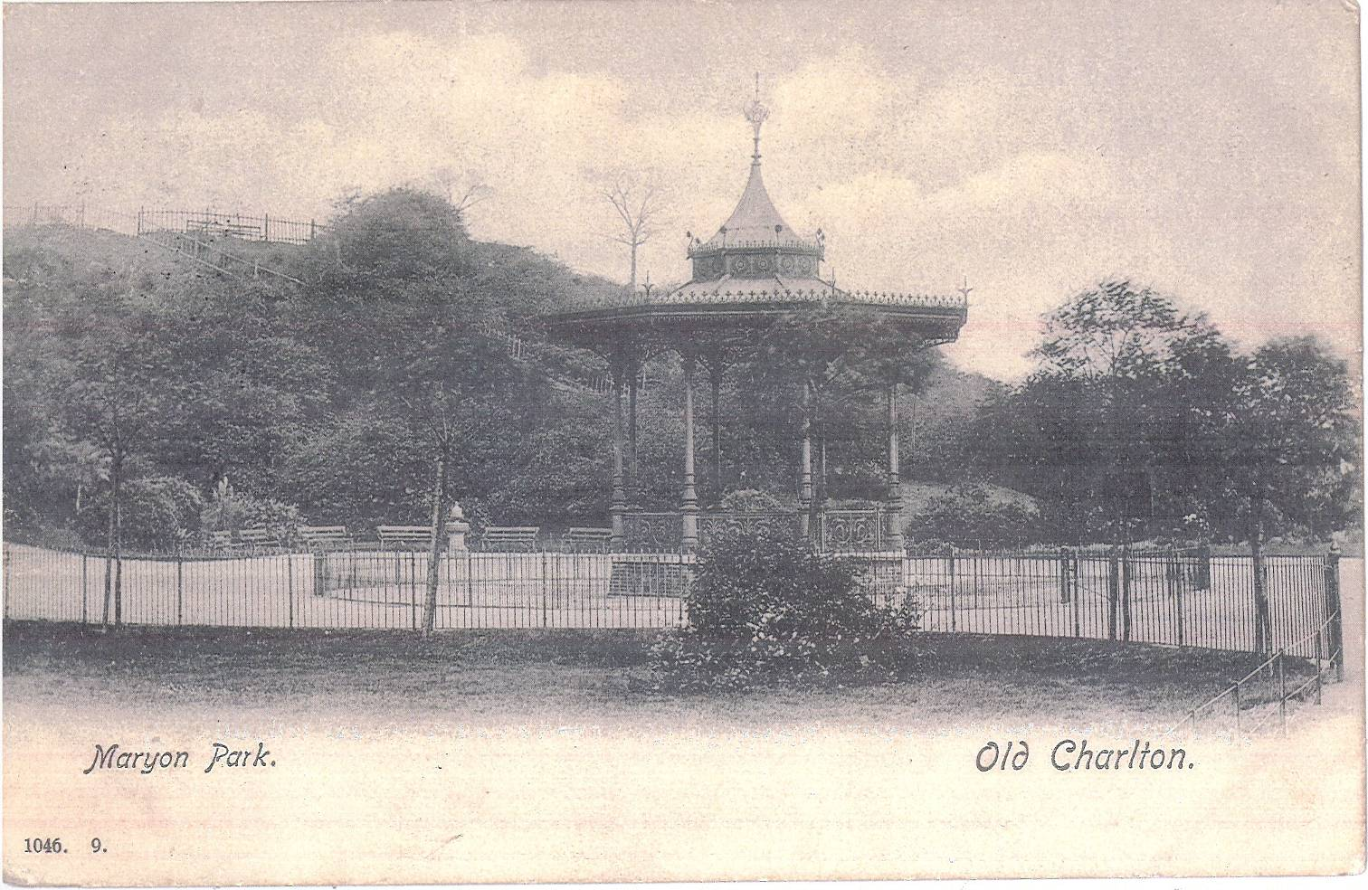
The grassed area was too restricted for cricket to be played, although one of the conditions of the gift was that kids from the training ship Warspite, which lay at anchor off Charlton, should be free to play. Five years later, Sir Spencer Maryon-Wilson presented one third of an acre more land for the formation of an open air children’s gymnasium with an additional entrance in the lower Woolwich Road. The following Year, a decorative iron bandstand replacing an old rustic one was also erected and over £4,000 spent on general improvements including a keeper’s lodge and toilets.

In 1908, a further seven acres of the disused sandpit were acquired, including Cox’s Mount and provision was made for another entrance from Maryon Road and a larger grassed area.

In 1925 and 1929, a total of eleven additional acres were purchased to allow for widening of Thorntree Road and a new southern entrance to the park by a flight of steps.

Apart from regular band concerts, the park was also the venue for the first LCC open-air theatre when the 300-year-old Earl Armstrong Repository Company was invited to perform.

During World War Two, Cox’s Mount was used by the Home Guard as a look out point.

Maryon Park featured extensively and atmospherically in the 1960’s cult-classic film Blow Up directed by Michelangelo Antonioni, starring Vanessa Redgrave, Sarah Miles and David Hemmings. A small commemorative plaque was installed in a recessed seating area next to the tennis courts. This was removed but found within the park and is currently with the park keepers.

Within the last twenty years, there have been significant changes to the north end of Maryon Park. When the Woolwich Road was widened, the area of terraced houses adjacent to the road was demolished to allow a large roadside space to be newly landscaped. This new space, including semi-circular seating areas and new trees and plants, became the counterpart to a corresponding new park (Barrier Gardens) across the road which led, at least in part, to the Thames Barrier.

Gilbert’s Pit History
The area known as Gilberts Pit was originally part of the ancient ‘Hanging Wood’. The dramatic topography that was present on the original ridgeline (now almost completely changed) was created largely by man made activity, probably dating back to the early Iron Age. The earthworks constructed at that time are believed to have provided the original site of the Charlton settlement.

Excavations and surveys carried out since 1780 culminated in 1915 when a more extensive excavation and survey was carried out by FC Elliston Erwood FSA. His report (published as The Earthworks at Charlton, London SE7) concluded that ‘Charlton was a native settlement during the first half of the Roman occupation’. The settlement is described as a large polygonal earthwork of probable pre-Roman age, with little evidence of occupation prior to the first century AD. The earthworks consisted of an inner area surrounded by a double bank and ditch. The inner area was approximately 7.5 acres; the total area covering 17.5 acres. The excavation revealed a probable period of occupation spanning across four centuries. The inhabitants were hut dwellers but there was additional evidence of light timber frame and daub buildings with tiled roofs. Artefacts of contemporaneous industrial technology were also found; flint chips, flakes, rough scrapers, bones, furnace bars, quernes, loom weights, nails, various bronze objects and two coins (from the reign of Claudius I, 41-45 AD). The bulk of the objects found unearthed date from 60-350 AD. The Bronze Age fragments found were the only ones discovered in the district. The finds are now displayed at the Heritage Centre.

The subsequent destruction of these early fortifications is largely the result of mineral extraction. As part of the manorial grounds held by the Maryon-Wilson family from 1767, the sandpits were being worked from late 18th century until 1889, managed by Mr E. Gilbert, fuelled by the industrial revolution.

The most notable of the Maryon-Wilson family to commercially operate the excavations was Sir Thomas Maryon-Wilson (1800-1869).
Sir Thomas also held manorial rights over a large part of Hampstead Heath and in addition to Gilberts Pit, conducted large scale commercial sand excavations in a pit on the West Heath section of Hampstead Heath, as well as his attempts to bar public access to and develop large sections of the Heath.

The attraction of the site to industry was largely due to the abundant reserves of sand, chalk and gravel of the exposed Tertiary series. The Thanet sand was in great demand for processes including casting and moulding of brass and iron, making glass? and was also used as floor surfacing on parlour floors before carpets became widely available.

In 1889, Sir Spencer Maryon-Wilson presented an area of the worked out mineral pits to the LCC, which later became Maryon Park. Gilberts Pit; the remainder of the sandpits, was purchased by the LCC in 1930. It is separated from Maryon Park by a prominent ridge at the northern end of which are the remnants of home guard trenches which were used during the Second World War as lookout posts.

In 1985, Gilberts Pit was designated as a site of Special Scientific Interest notified by the Nature Conservancy Council under the Wildlife and Countryside Act 1981 for the geological interest of the site. Charlton sandpit exhibits one of the most complete sequences of Lower Tertiary, Palaeocene rocks in the world, including the type section of the Woolwich Beds. Exposed in the south-western faceoff the pit are the Blackheath, Woolwich and Thanet Beds deposited approximately 50-55 million years ago.

The sequence of sands and clays exposed in the pit have been the subject of much detailed scientific research providing vital information about the environment, climate and geography that existed in Southern England during the Lower Tertiary. Charlton Sandpit has also been classified by the London Ecology Unit as a site of Borough Grade 1 importance for Nature Conservation. Even though only a small fragment of the ancient Hanging Wood survives at the southernmost tip of the site, the site supports a good range of habitats and a particularly diverse collection of plant and animal species for an inner London site.

The site is included in the Green Chain Walk but is not a public right of way.

In 1997 a 2 metre high security fence was erected around parts of the site, including dangerous areas as well as a footpath system. In 1989, the London Wildlife Trust erected a security fence around the ecology area.

There is an ongoing problem of continual erosion of the geologically valuable features as well as the nature conservation features of the site.
APPENDIX II

Gilberts Pit PDO’s
Potentially Damaging Operations (PDO’s)

Operations likely to damage the special interest
Site name: Gilbert’s Pit (Charlton), Greater London
Ref. No OLD1003340
Type of Operation
2 Grazing.
4 Mowing or other methods of cutting vegetation.
7 Dumping, spreading or discharge of any materials.
11 The destruction, displacement, removal or cutting of any plant or plant remains including tree, shrub, herb, hedge, dead or decaying wood, moss, lichen, fungus, leaf-mould, turf.
12 Tree and/or woodland management+.
20 Extraction of minerals, including sand and gravel and chalk.
21 Construction, removal or destruction of roads, tracks, walls, fences, hardstands, banks, ditches or other earthworks, or the laying, maintenance or removal of pipelines and cables, above or below ground.
22 Storage of materials on or against any rock face.
23 Erection of permanent or temporary structures, or the undertaking of engineering works, including drilling.
24 Clearance of large stones, loose rock or scree and battering, buttressing, grading or hydroseeding rock-faces and infilling of pits.
26 Use of vehicles or craft likely to damage or disturb rock-faces.
27 Recreational or other activities likely to damage rock-faces.

+ including afforestation, planting, clear and selective felling, thinning, coppicing, modification of the stand or underwood, changes in species composition, cessation of management.

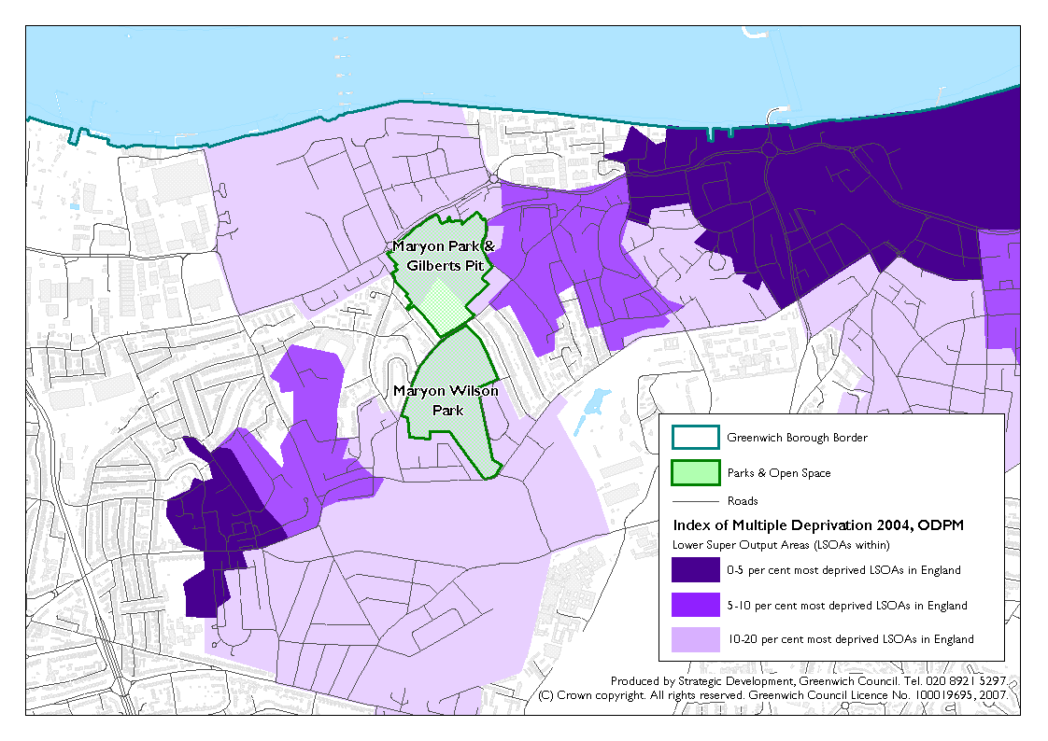
APPENDIX III: Demographic Context

APPENDIX IV

Extracts from 1997 plan

PART 4 - MANAGEMENT PRESCRIPTION
4.1 DETAILED PRINCIPLES
To avoid constant repetition within the text of the compartments and projects sections, and in order to emphasize their importance, a number of detailed principles are listed here. These represent 'good practices' which are based upon sound ecological principles, good land and facility management and cost effectiveness.
4.1.1 Consultation
Management activities will, through liaison and consultation, take account of the views, requirements and advice of relevant government and non governmental organisations. In particular English Nature will be consulted prior to any works listed as likely to damage the geological SSSl are undertaken?. Consideration through appropriate consultation will be given to the needs and opinions of the community and local residents, including those with adjoining properties.
4.1.2 Habitat and Community Conservation
It is not always possible to manage a habitat to benefit equally each of the different plant and animal groups. Every effort will be made to provide suitable conditions for the conservation of the range of habitats and communities present on the site.
4.1.3 Prevention of Local Extinctions
To prevent accidental local extinctions, particularly of invertebrate species and to encourage natural, recolonisation, management projects will, where possible, be limited in size of area affected.
4.1.4 Temporary Notices
These will be erected where management operations of likely public concern, e.g. tree felling, are taking place. The notices will explain the work being carried out and the reason for it.
4.1.5 Monitoring
Management work will be carefully monitored (before, during and after), to ensure that the objectives are being achieved and as a valuable scientific record.
4.1.6 Timing of Management Operations
No management works, except grass cutting, footpath maintenance and other infrastructure works will take place between March and October. It is between these months that disturbance to nesting birds is most likely to occur.
4.1.7 Introductions
Natural colonisation or recolonisation by plants or animals is always to be preferred. Deliberate introductions or reintroductions will only be performed after careful consideration of a) the wildlife value, b) historical suitability for the site and c) the possible detrimental effects on existing wildlife. Only native stock of local provenance will be used. No introductions will be made during the life of this management plan.
4.1.8 Grassland Cutting
This applies to all areas except the central amenity grassland area. Grassland areas will be cut to between 2 and 3 inches high in August or September. Cuttings will be stacked in discrete piles on site preferably in areas of scrub and distinctly not on existing grassland habitat.

4.1.9 Fires
No material will be burned on site.
4.1.10 Dead Wood
Dead wood resources, both standing and felled, and especially of larger material, will be encouraged provided public safety is not affected. Large logs may be imported from other sites in the Borough.
41.11 Felling and felled material
Felling or coppicing will only take place between October and March. Logs will be stacked in piles within the woodland, brashings and smaller material can be chipped and stored in the woodland in discrete piles (but not spread) or removed from the site.
4.1.12 Vehicles
No vehicles will be brought on site unless the ground is firm.
4.1.13 Chemicals
The only chemical to be used within the site will be Ammonium sulphamate (Amcide). It will be used when appropriate to kill stumps following scrub clearance or similar operations. Great care will be taken to limit the application to the target. Stumps will be treated within 24 hours of felling. National legislation and Council policies will be adhered to.
4.1.14 Furniture
All structures, notice boards, seating etc. will be designed to withstand or discourage vandalism and positioned where they will not be intrusive. Tropical hardwoods will not be employed in the construction of these items.
4.1.15 Vandalism
All structures or features will be repaired or tidied as soon as possible after damage, in order to discourage further vandalism. Litter clearance will be a priority.
4.2 COMPARTMENTS
Compartments have been chosen with ease of location rather than habitat type being the major criteria. In general, fence lines have been used to separate compartments. The compartments used in 1990 have been slightly modified to reflect the changes that have happened since then.
DETAILED PRINCIPLES section 4:1, and the WORK SCHEDULE 4.4, are to be read before any management operations are undertaken.

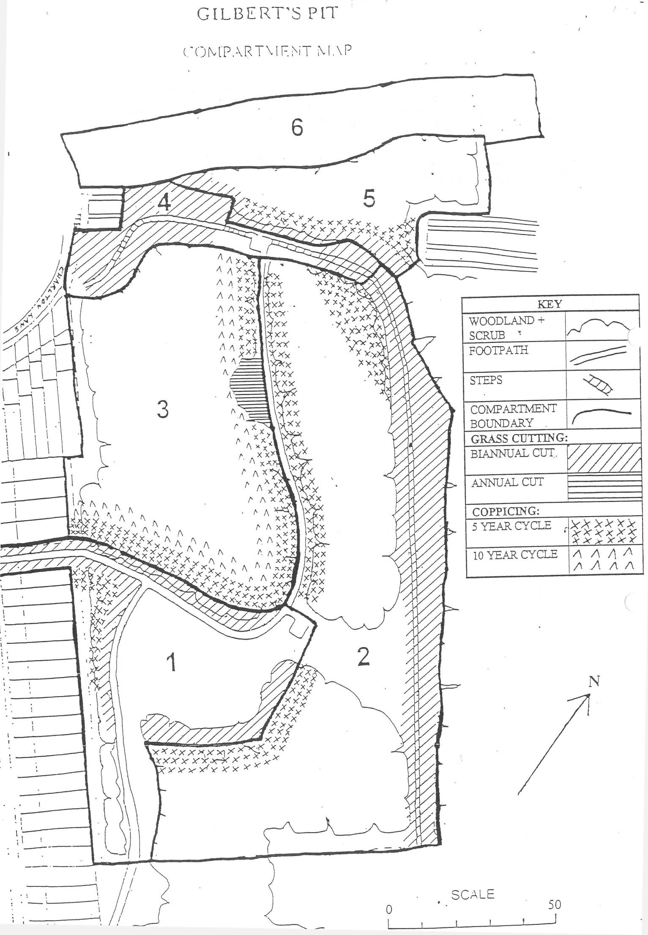

4.2.1 COMPARTMENT 1 Description
1a - Central grassland area
This is closely mown during this season. Grasses present included false oat-grass, cocksfoot, annual meadow grass Poa annua and perennial rye-grass. Most of the herb species are those to be expected with this type of management but mugwort Artemesia vulgaris, white bryony Bryonia dioica, hardheads, lucerne Medicago sativa, selfheal Prunella vulgaris and bird's-foot-trefoil Lotus comicuiatus were also recorded here. Stag's-horn plantain occurs here and nowhere else on the site. Two species which were recorded in the 1990 survey, field woodrush and thyme-leaved sandwort were not found during this survey.
1b/1c - Scrub/tall herbage - surrounding football pitch
This strip around the football pitch is not mown so regularly, scrub and tall herb communities have developed here. Young trees and tree saplings growing here include 'hawthorn, elder Sambucus nigra, sycamore, apple Malus domestica and ash. Other species include prickly lettuce Lactuca semoia, hop Humulus lupulus, bramble Rubus fruticosa, nettle, black horehound Ballots nigra and hawkweed oxtongue Picris hieraciodes.
1d - Scrub and young woodland on western boundary
This strip runs along the west side of the footpath from the entrance in Thorntree Road to the east- west footpath on the northern edge of this compartment. The southern section is more open with more mature trees but a poor herb layer. The northern section is dominated by hawthorn with sycamore and ash emerging. The ground flora here is sparse to almost non-existent. Other trees and shrubs recorded here included; yew, holly, cherry Prunus avium and buddleia. Herb species include cow parsley, feverfew Tanacetum parthenium and garlic mustard Alliaria petiolata. Between the woodland and the footpath several ruderals were present including; rosebay willowherb Chamerion angustifolium, wild parsnip, curled dock Rumex crispus and Canadian goldenrod Solidago canadensis. Meadow anthills occur in this strip because it is not regularly mown.
Aim
- To enhance the nature conservation interest of the grasslands in compartment 1b/1c/1d.
- To establish a scrub edge to woodland in 1d.
- Central grassland (1a) - consider relocating football pitch. The grassland could then be entered into meadow management and receive a single cut and removal a year.

Management Prescription
- Establish a biannual cutting regime on the grasslands in strips in 1b and 1c.
- Clear fell and herbide stumps in first 5m in 1 d in year 1, then cut grass in year 3.
- Coppice remaining trees in 1d, 3 metres back towards the fence, then coppice on a five year cycle.

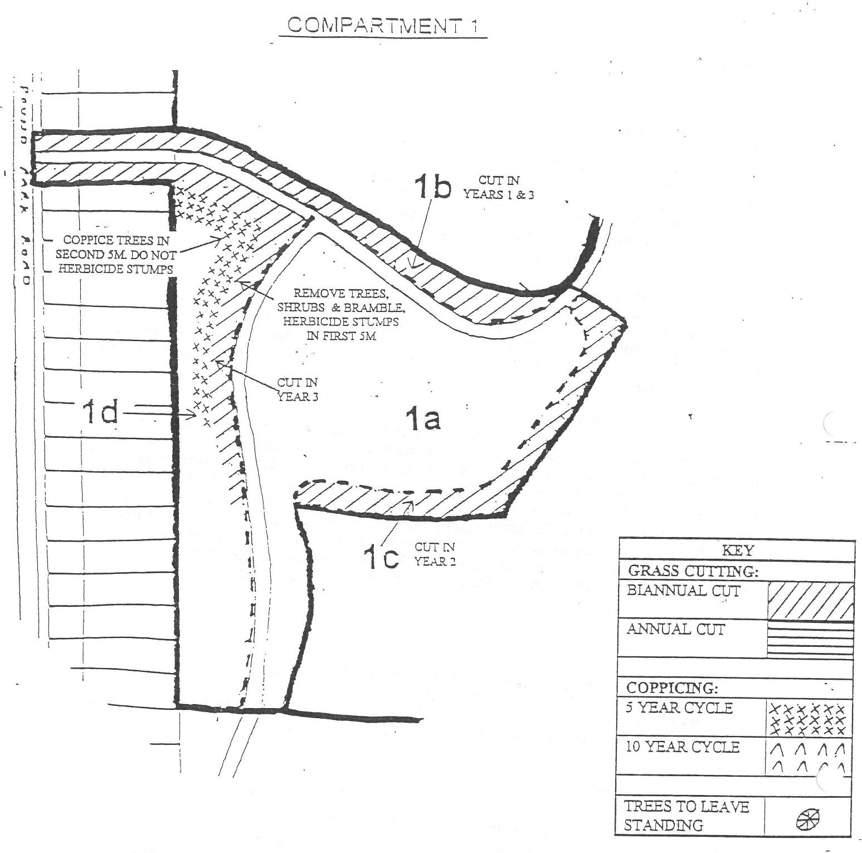

4.2.2 COMPARTMENT 2
Description
The exposure of the geological sequence, which is the principal reason for the site being a SSSI, has been further eroded since 1990. The driven spile fence has now disappeared under the talus making it even easier for children to use the slope as a slide. The dense canopy of the woodland has led to a reduction of the scrub layer allowing easier access to the slope. Protecting the exposure must be given the highest priority.
2a - South escarpment
Sycamores with hawthorn beneath are the dominant trees on the slopes, particularly the south-facing slope. On the ridge oaks Quercus robur and Quercus x rosacea dominate. Elder is frequent at the bottom of the slopes. Sooty bark disease is evident in much of the sycamore, causing die-back and allowing more light through in places. Several dead silver birch Betula pendula (possibly due to water stress) are also present. The slopes are mostly bare due to trampling and shading. The top of the slope is subject to erosion in places where gaps occur in the woodland. Where there is sufficient light, patches of bramble occur along with patches of dense regenerating sycamore, ash, hawthorn and broom. Otherwise the ground flora is very poor, with a few species occurring on the top including Guernsey fleabane, hawkweed Hieracium species, nipplewort Lapsana communis and red clover Trifoiium pratense.
2b - North escarpment
Sycamore dominates the canopy here with ash, hawthorn and elder frequent. The slopes are reasonably well vegetated but erosion is causing a lot of damage. The southern section which is used as a slide is completely devoid of vegetation and the area affected has widened since 1990. The trees at the base of the slope have been coppiced in the past. The ground flora includes cow parsley, bramble, large bindweed Calystegia silvatica, black horehound, ivy and garlic mustard. There is evidence of past dumping at the base of the slope leading to a general nutrient enrichment.
2c - Top grassland
Acid grassland with patches of gorse and broom scrub predominate with some young trees particularly hawthorn, holm oak and pedunculate oak. Fires have occurred here recently which along with the trampling are probably why the grassland has survived here and not become scrub as has happened elsewhere on site. Communities of Polytricum mosses and Cladonia lichens occur here along with sheep's sorrel, common bent Agrostis capillaris, cat's-ear, mouse-ear hawkweed, perforate St. John's-wort Hypehcum perforafum and early hair-grass.
Aim
- To protect the geological exposure from further damage.
- To establish a scrub edge in the western edge of 2a and 2b.
- To maintain 2c as acid grassland and .prevent any further scrubbing up.

Management Prescription
- Obtain funding for and install high security fencing.
- Coppice trees between footpath and fence on western edge of 2b on a five year cycle (do not fell the large ash indicated on the map).
- Coppice trees 5m back from the fence on north-western edge of 2a on a five year cycle (do not fell any dead sycamore or birch in 2a unless necessary for safety reasons).
- Establish a biannual mowing regime in 2c; do not allow scrub to further encroach grassland.
- Coppice northern section of 2b where indicated on the map to restore the view from the ridge top, on a five year cycle.

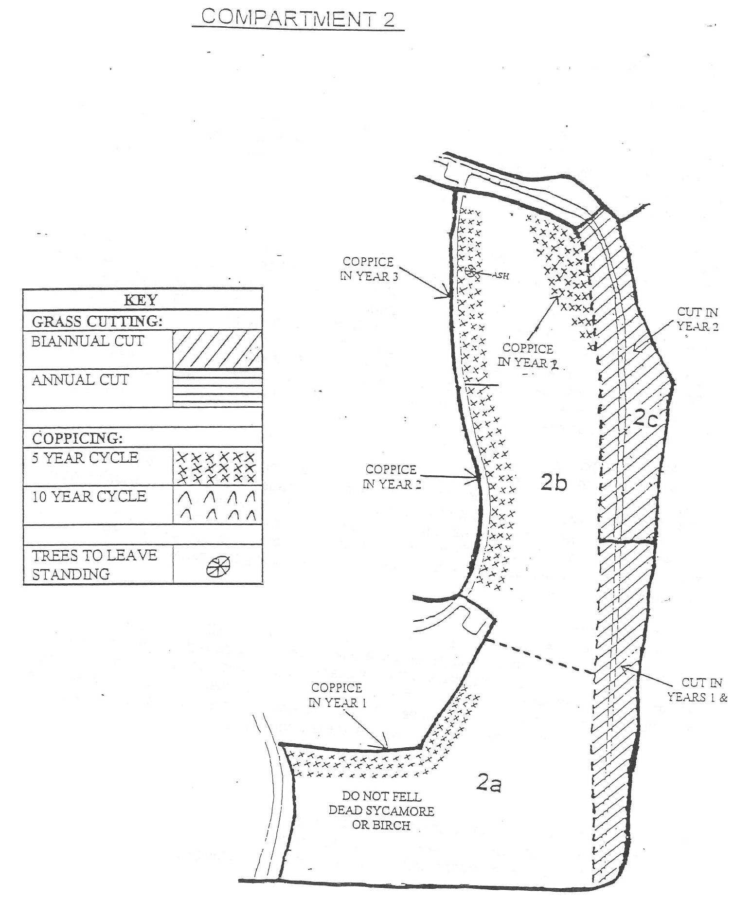

4.2.3 COMPARTMENTS Description 3a - Main woodland compartment
The canopy is dense and ivy is abundant on the ground and growing up the trees. The main tree species here are hawthorn, sycamore, ash, holm oak and pedunculate oak. Apart from the ivy there is very little ground flora. Small numbers of herbs exist in the few places which are not densely shaded, these include; cow parsley, garlic mustard, black horehound', large bindweed, bittersweet .Solatium dulcamara and common chickweed Stellaria media.
The area looks dark and forbidding with the steep slopes making access, particularly to the western part, difficult. A lot of dumping (including shopping trolleys) has taken place on the western boundary in the past and there is a car graveyard at the bottom of the slope. Management of this compartment, except for the edges, would be difficult and a policy of non-intervention is recommended here for the time being. In the longer term, when management of the overall site is taking place, it would be appropriate to create clearings within the compartment.
3b - Open Area - On North-South Footpath
This area is largely free of trees apart from one mature coppiced sycamore and a young eider. The flora is dominated by nettle and large bindweed, largely due to nutrient enrichment from past dumping. Otherwise it is very species poor with small numbers of cow parsley, common couch Eytrigia repens, cleavers Galium aparine and white dead-nettle Lamium album.
3c - Grassland
This section of neutral grassland is mown regularly. It appears to be of less interest, ecologically, than the acid grasslands 2c, 4b and 5b. Species recorded here include red fescue Festuca rubra, creeping cinquefoil, dove's-foot crane's-bill Geranium molle, creeping thistle Cirsium arvense, smooth hawk's-beard Crepis capillaris and common mouse-ear Cerastium fontanum.
Aim
- To establish a scrub edge habitat to southern and eastern edges of the wood.
- To maintain the remainder of the woodland with a non-intervention policy for the time being.

Management Prescription
- Establish a five year coppice cycle in the first five metres of the woodland and a ten year cycle in the second five metres as shown on the map (do not fell the ash, rowan and elm indicated).
- Cut the nettle bed (3b) annually and stack arisings on the western edge of the clearing.
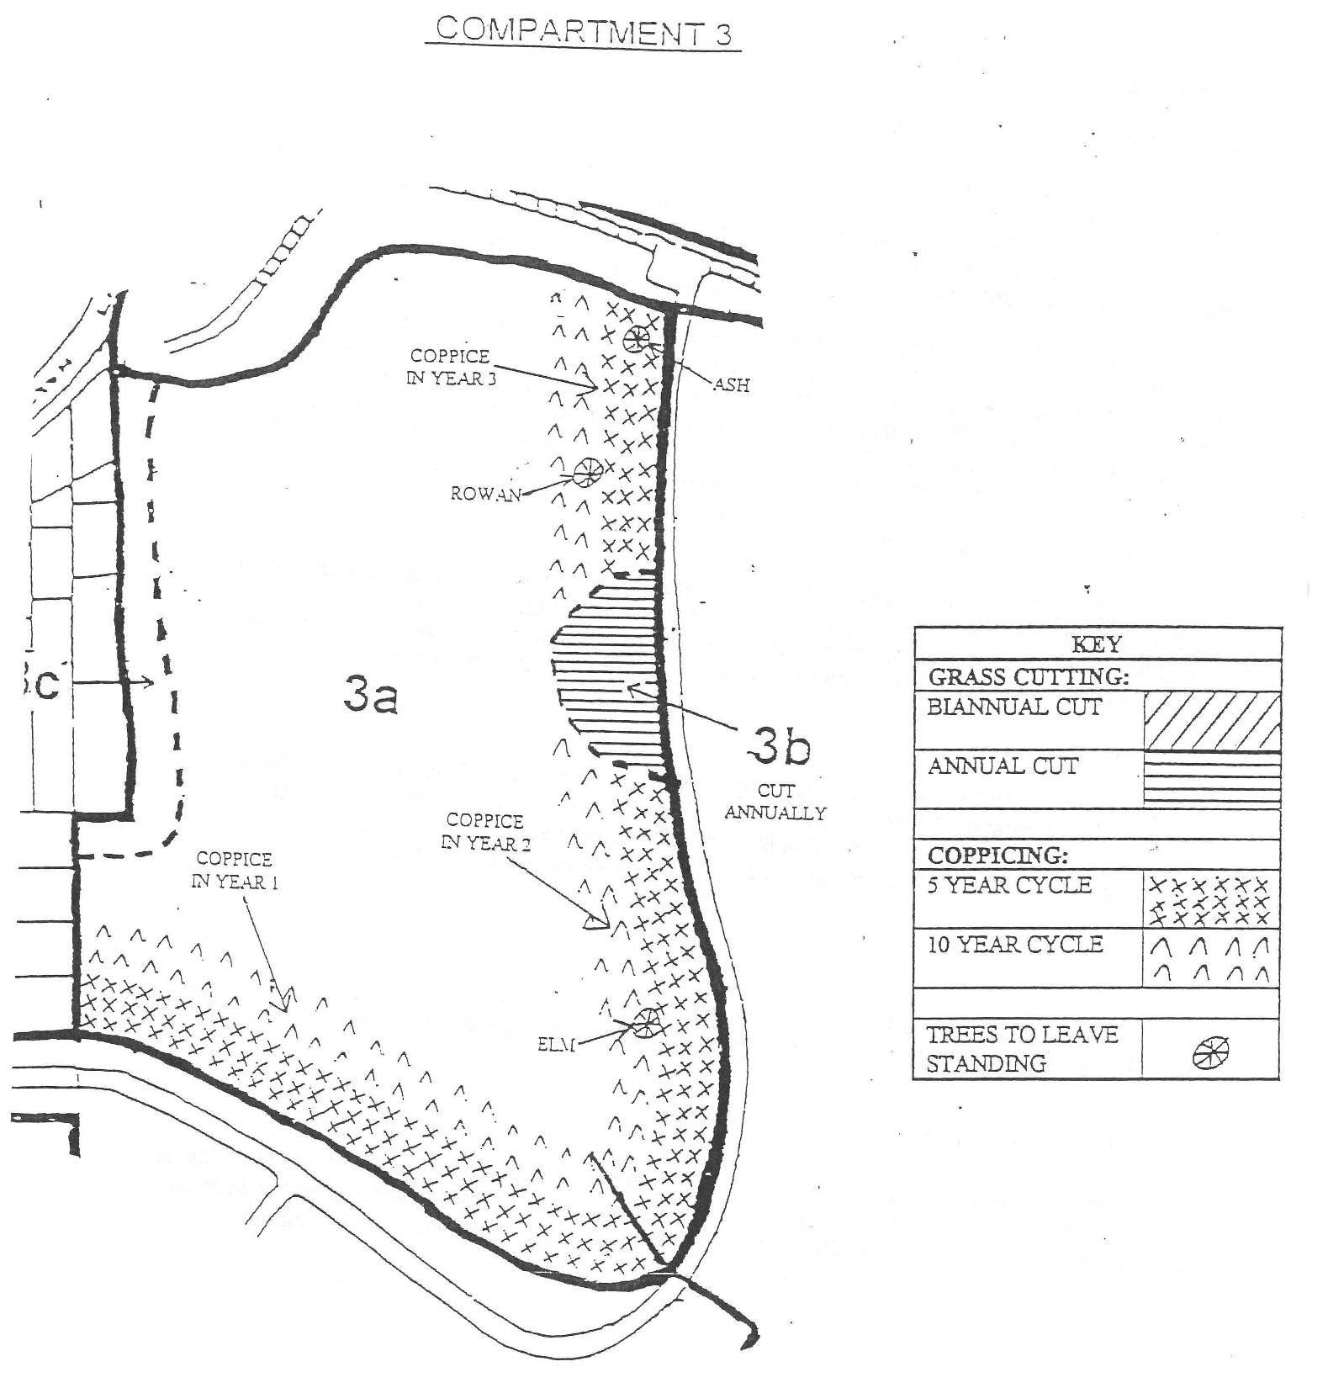

4.2.4 COMPARTMENT 4
Description
4a - Lower Western Section
This area has some mature oaks and sycamore, which have been coppiced in the past. Many young trees are established and there are hundreds of tree and shrub seedlings. The grassland is not of very high quality. Herb species diversity is relatively poor. Bramble and ivy occur in large patches but are not completely dominant.
This section is slightly more open than most of the woodland on the site and has some grassland remaining.
4b - Viewing Area •
This is largely acid grassland. Creeping bent and sheep's sorrel predominate. Cat's-ear and early hair-grass also occur. There are patches of Polytricum mosses and Cladonia lichens. A patch of gorse exists along with some young oaks and silver birches. As with the other valuable grassland areas on the site, this area is in danger of scrubbing up, although trampling seems to be keeping it open on most of the ridge top.
The fence installed to protect the geological feature is now non-existent along much of its length. The posts have been used to lever away the top of the slope and the fence is now lying partly buried several metres down the slope. Buddleia, bramble and grasses have now colonised part of the slope.
The views from the ridge have now been lost to a large extent, especially the view to the south. Trees have grown high on the top of the slopes on both sides obscuring the views.
Aim
- To maintain 4b as acid grassland and prevent any scrubbing up.
- To restore the views from the ridge top.
- To encourage more grassland species in 4a by controlling scrub re-growth.

Management Prescription
- Remove tree, shrub and bramble saplings from 4a and herbicide stumps.
- Establish a biannual cutting regime in 4a and 4b.
- Restore views from ridge top by coppicing sections of Comps. 3 & 5 (as discussed in the prescription for those compartments).

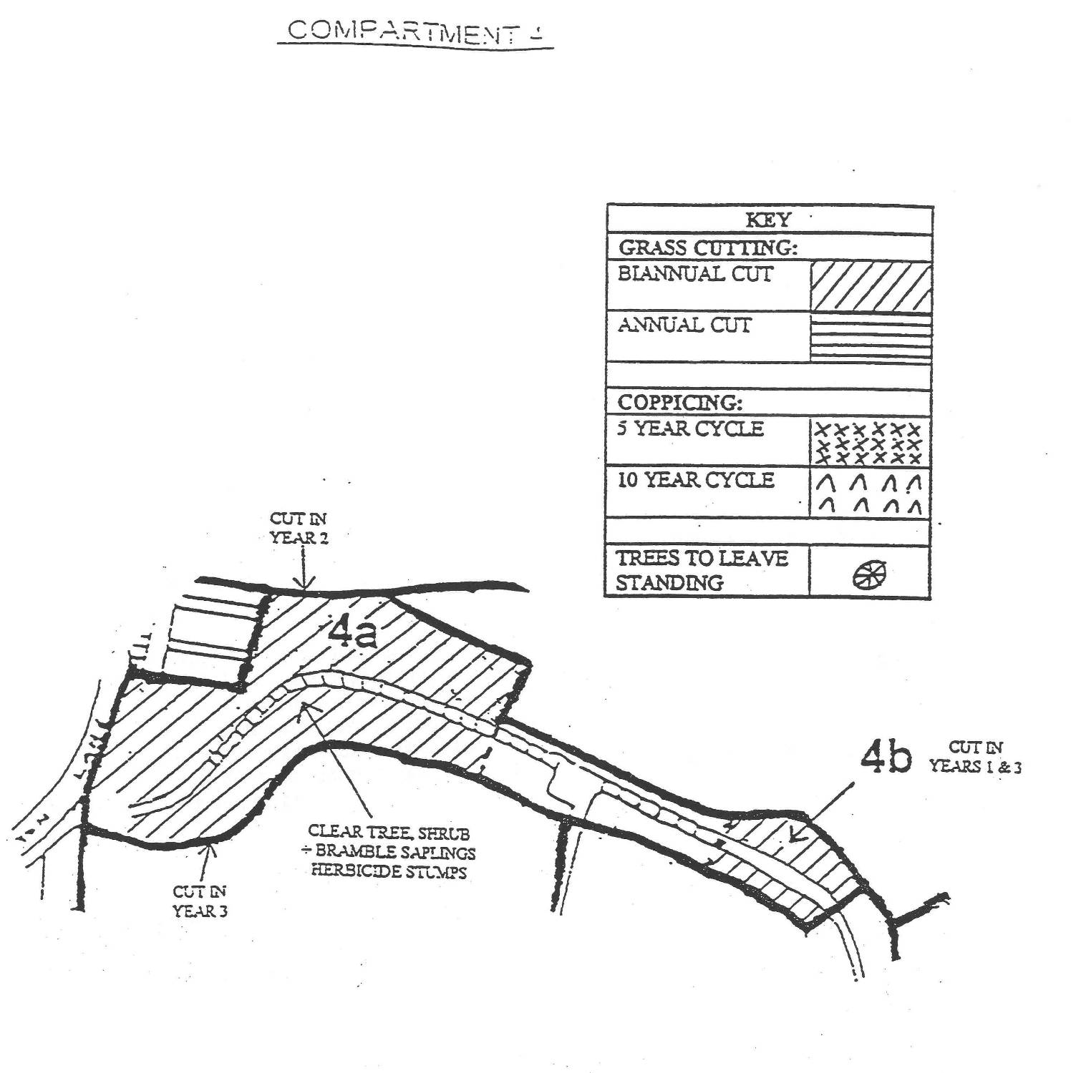

5. COMPARTMENT 5

Description

The house, back gardens and neutral grassland that were at the base of the slope here in 1990 have now gone. It also appears that part of the woodland has been felled. The widening of Woolwich Road is the cause of this transformation. The remaining area of the land take has been terraced and is in the process of being landscaped. This area has now been placed in compartment 6.

The grassland and scrub edge to the woodland were an important stopping off point for migrating birds including a variety of warblers, particularly when inclement weather conditions prevailed, they would ‘ditch’ here. This is probably due to the site’s position as a landmark with suitable habitat on the bird’s migration route. This habitat has now been lost.

The upper slopes here are very steep and covered in dense scrub making access difficult. Parts of this area were surveyed from vantage points.

This compartment consists mainly of semi-mature woodland with dense scrub. The more mature trees are at the base of the slope with younger tones above. The most common tree species in the section are hawthorn, sycamore, ash, pedunculate oak and holm oak. Gorse is also common at the top. Artichoke gall on young oaks which is caused by the wasp Andriscus fecundator was noted at the top of the slope. The woodland at the top of the slope has grown up and is obscuring the view from the ridge top.

The acid grassland at the top has scrubbed up considerably since 1990 and will continue to do so if left unmanaged. Small communities of Polytricum mosses and Cladonia lichens still exist, but blue fleabane which had a good population here in 1990 is now down to a handful of individuals. Creeping bent Agrostis stolonifera, hardheads, red fescue and sheep’s sorrel are still just about surviving. One voluntary workday was carried out by the Lewisham Group of the London Wildlife Trust in 1990, clearing scrub from this area. The fence between here and the ridge has been breached in several places.

Aim
- To restore the extent of acid grassland in this area.
- To create a scrub edge around the grassland
- To restore the views from the ridge

Management Prescription
- Remove and herbicide tree, shrub and bramble saplings 5m back from fence on southern edge, then establish a biannual cutting regime here.
- Coppice scrub 5m back from this grassland on a 5 year rotation.

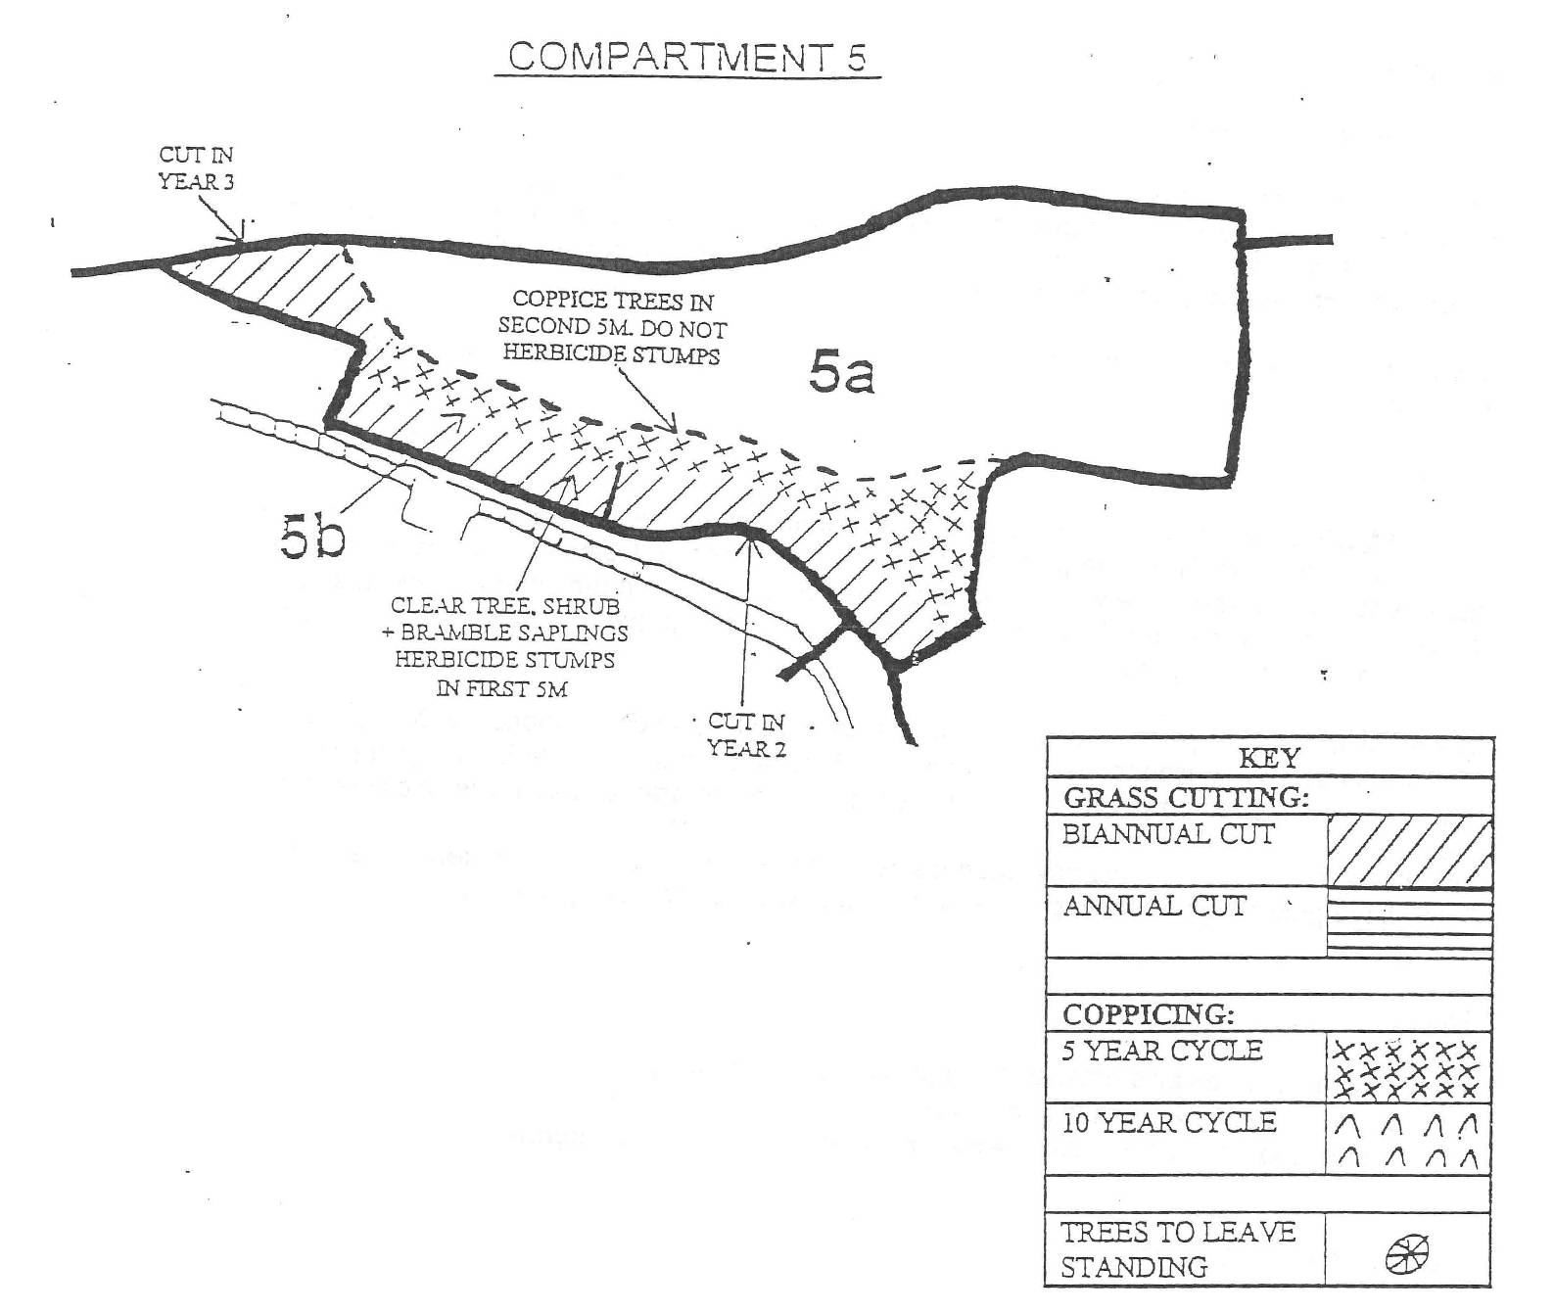

4.2.6 COMPARTMENT 6
Description
This area was recently created when the road widening on Woolwich road and the subsequent demolition of the houses north of the site took place. The topography now consists of a combination of gentle slopes, curves, humps and terraces. It has been planted up with saplings and standards of the tree species listed below. Several of the standards are dead and many of the remainder are showing signs of dieback. Bundles of whips of dogwood Comus sanguinea, guelder rose Viburnum oputus, dog-rose, blackthorn Prunus spinosa, other Prunus species, ash and privet Ligustrum vulgare have been dug in to the soil. Hundreds of these are now dead. The standards that have been planted include field maple Acer campestre, silver birch, hazel Corylus avellena, holly, London plane Platanus x hispanica, cherry Prunus species, pedunculate oak and rowan Sorbus aucuparia.
Wild tree saplings are invading this area from the woodland and in general look a lot healthier than those that have been planted. It is difficult to know why the species that exist in the woodland were planted here as they are capable of colonising the area themselves successfully. Where have the whips that have been planted come from? Many of them are native species but most of the horticultural trade supply European genotypes.
Some of this area has been herbicided, some cut, some herbicided and cut??? and some left unmanaged. An interesting range of ruderal species have managed to colonise in areas not herbicided including several typically arable weeds which are declining nation-wide. Com spurrey Spergula arvensis, field pansy and black-grass Alopecurus myosuroides all occur here.
If the normal amenity landscaping method continues to be followed here it would be expected that cultivated flowers will be planted in beds and a lawn grass seed mixture may be sown and mown regularly. This will be of little use to wildlife in the area.
The most important habitat loss here is the grassland that formerly existed between the woodland and the houses. This area could be managed to maximise its conservation interest and complement the remainder of the site by allowing grassland to become established here. The quality of this grassland would be improved if the topsoil introduced here was removed.

4.3 3 YEAR SCHEDULE OF PRIORITY WORKS
The highest priority is the installation of a high security fence around the geological exposure.
The priority in terms of habitat management on the site is the grasslands. Priority has also been accorded to restoring and/or maintaining views. The priorities are listed by compartment in bold below. The remaining works are essential to the long term conservation of the site but can be phased in at a later stage if necessary.
Read Detailed Principles Section 4.1 and Compartments Section 4.2 (which includes detailed maps) before any management operations are undertaken.

Comp  Number | 1998 | 1999 | 2000
1 | Cut grass in area 1b | Cut grass in areas 1c | Cut grass in area 1 b & 1 d
 | Clear trees and scrub in area 1d | -
 | Herbicide stumps in first 5m from footpath
2 | Install high security fencing | Cut grass in area 2c north section | Cut grass in area 2c south section
 | Cut grass in area 2c south section | Coppice trees in 2b south section | Coppice trees in 2b north section
 | Coppice trees in area 2a | Coppice trees in area 2b south and west of viewing platform
3 | Coppice trees on south side of- compartment | Coppice trees on east side of comp. south of 3b | Coppice trees on east side of comp. north of 3b
 | Cut area 3b | Cut area 3b | Cut area 3b
4 | Cut grass in area 4b  Clear tree, shrub & bramble saplings in area 4a, herbicide stumps | Cut grass in area 4a west of footpath | Cut grass in area 4b  Cut grass in area 4a east of footpath
5 | Clear trees, shrubs and bramble in area 5b 10m in from fence and eastern triangle. | Cut grass in area 5b, east section, 5m in from fence | Cut grass in area 5b, west section, 5m fn from fence
 | Herbicide stumps 5m from fence

APPENDIX V

Policies and legislation affecting park management

As highlighted earlier in the plan, Greenwich Council’s Parks and Open Spaces department operates within a wide framework of national, regional and local policy statements and strategies. The main documents impacting on the development of this plan are listed below.

The Greenwich Strategy
The Greenwich Strategy sets out the vision for Greenwich Borough as being the place to live, work, learn and visit. This vision underpins all of the strategies produced by Greenwich Council and directly impacts on all service plans and service delivery.

The Cultural Strategy
Parks and Open Spaces is one of six ‘areas’ considered by the Cultural Strategy. The Strategy has five over-arching themes: - Equality and Access, Sustainability, the Cultural Economy, Achievement and Excellence and Partnerships. All of these aims are relevant to this management plan and have been considered in developing the opportunities and priorities for this site.

Green Space Strategy
The Green Spaces Strategy sets out the Council’s strategic intentions for its green assets and its vision of the positive contribution that Greenwich’s open networks make to our lives.
The thematic objectives (community safety, biodiversity, education and culture, culture and events, tackling inequality, sport, health and well being) are all relevant to this management plan.

Draft Biodiversity Action plan
The Greenwich Biodiversity Action Plan will be the first co-ordinated approach to conserving Greenwich’s biodiversity. The aim of the plan is:
‘To ensure the conservation, enhancement and public appreciation of the biodiversity of the London Borough of Greenwich’.

The Biodiversity Action Plan focuses on locally important habitats and species and has actions drafted to ensure that they cover all relevant habitats and species. Initially actions may be focussed on those under the most pressure or where most advantage can be gained. However, it allows for all important habitats and species to be covered.

The Biodiversity Action Plan has been developed in partnership with local and regional groups and organisations and is currently in draft form awaiting adoption by the Council.

Parks and Open Spaces Service Plan
The Parks & Open Spaces department aims to develop, manage, ensure accessibility and maintain to a high standard the borough’s Parks, Open Spaces, Woodlands, Tree Stock, Cemeteries, Playgrounds, Sports Pitches, Allotments and other outdoor facilities. To meet the needs of the community and deliver the Council’s core objectives where applicable to the service, and specifically regarding the provision of a clean and well cared for environment and supporting Health and Quality of Life for the local community.

ISO 9001:2000 – Quality Management System
Quality Management System ISO 9001: 2000 is used by organisations to manage their tree maintenance activities and resources to guarantee a quality service. This management system is based on eight quality management principles:
- Customer Focus
- Leadership
- Involving People
- Process Approach
- System Approach to management
- Continual Improvement
- Factual Approach to decision making
- Supplier relationship, which benefit both sides.
At the time of writing, the Parks & Open Spaces department is currently ISO 9001 accredited, and aims to maintain that accreditation indefinitely.

ISO 14001:2004 – Environmental Management System
Parks and Open Spaces are committed to ensuring our activities are undertaken in an environmentally friendly manner and our effects on the environment are controlled. The services Environmental Management System is certified to the internationally respected ISO 14001 Environmental Standard.

Unitary Development Plan
Local Councils have a duty to prepare a Development Plan by law. The Greenwich Unitary Development Plan (UDP) sets out the vision for use of the land in the Borough, and provides the main guidance for making decisions on individual planning proposals. The document is intended to cover the period 2001 – 2011 (or 2016 in some instances) it is a legal document with the following purposes:-
- To provide a framework of acceptable uses within the Borough, defining areas where development is not desired or where it needs to be carefully directed and;
- To provide a detailed basis for the control and development

Maryon & Maryon Wilson both share the same designations in the UDP. Those designations are as follows: -
- Metropolitan Open Land (MOL)
- Green Chain
- Green Chain Walk
- Area of Special Character of Metropolitan Importance
- Conservation Area
The UDP may be viewed at the Directorate of Regeneration, Enterprise and Skills, Planning Department, Crown Building, 5th floor, 48 Woolwich New Road, SE18 6HQ, or alternatively at a local library.

Metropolitan Open Land
The UDP designates Maryon & Maryon Wilson as Metropolitan Open Land (MOL). Policy references O1, O2, O3 and O4 under the section ‘Protecting Open Land’ set out what the acceptable land uses and allowable developments are within areas designated as MOL. These policy references are too lengthy to reproduce here. The policies are broadly meant to control development or alterations to existing land that would be inappropriate to MOL and have an adverse affect on the character and usage of the open space.

Green Chain
The UDP also designates the park as Green Chain. Policy reference O5 under the section ‘Protecting Open Land’ sets out what the objectives of this designation are. The objectives are as follows:
To improve and encourage the provision of suitable recreational facilities, with an emphasis on those serving a wide area of South East London and/or requiring open land.
To safeguard the open land from built development and maintain its positive contribution in providing a visual and physical break in the built-up area of London.
To conserve and enhance the visual amenity and ecological aspects of the landscape.
To improve public access to and through the area.
To promote an overall identity for the area in order to increase public awareness of available recreational facilities.
To encourage the collaboration and co-operation of the various public and private agencies, owners, organisations, clubs, etc. in the area to achieve the above objectives.
For the extent of the Green Chain Area, refer to the UDP proposals map and second draft alterations maps.

Community Benefits
O10 The Council will seek to secure improvement and enhancement of existing parks and public open spaces, where major development places increased demand on existing areas, and, where appropriate, the creation of new parks and public open spaces in line with Policies O9 and C3, through planning obligations and conditions on planning permissions in line with Policy SC2.

Park Facilities
O12 The Council will seek to enhance open space by the provision and encouragement of appropriate park facilities (e.g. seating, children's play equipment, refreshment facilities, outdoor tennis courts, pitch and putt, sports pitches and changing facilities and Arts, Culture and Entertainment facilities, such as open air performance spaces, sculpture and visual imagery and areas for cultural exhibition and study) within suitable parks and public open spaces. Facilities should be of a high standard of design and quality and respect local nature conservation interests. Such facilities should be safe to use and accessible to all. (See Policies D5, D6 and D7).

Green Chain Walk
Policy O14 refers to the Green Chain Walk, which runs through .
O15 Existing footpaths will be safeguarded and new footpaths created to and through open spaces and places of interest, where they do not adversely affect nature conservation. The Council will endeavour to create a signposted network of continuous and circular routes. In particular the ‘Green Chain Walk' footpath network will be improved and extended and new links created wherever possible.

The UDP then says that the Mayor’s Transport strategy has identified the Green Chain Walk as being one of six strategic walks in London Section 2.4

Areas of Special Character
Also, the Greenwich UDP in part 2.6 refers to the parks as part of a larger area designated as Special Character of Metropolitan Character.

D28 Within Areas of Special Character defined on the Proposals Map, special consideration will be given to the safeguarding, restoration and enhancement of character, scale and quality of open spaces and associated buildings. Skylines and distant views both to and from the Areas of Special Character will be protected.

Conservation
Maryon and Maryon Wilson Parks are part of a wider area designated as a Conservation Area. Section 2.6 of the UDP sets out the policies relating to Conservation areas and is too lengthy to reproduce in this document, but the main thrust of the policies is to conserve and enhance historic landscapes by use of urban design principles, design statements and ecological surveys to assess and approve any developments in a sensitive and appropriate manner.
Please see the 2006 adopted UDP part 2.6 for comprehensive details on Conservation areas, as the details are too lengthy to reproduce here.

Area of Archaeological Potential
The UDP designates Charlton House Grounds; up to the Ha-ha is an area of potential archaeological significance and that policy D30 in the UDP sets out provisions for planning

D30 The Council will expect applicants to properly assess and plan for the impact of proposed developments on archaeological remains where they fall within ‘Areas of Archaeological Potential' as defined on the constraints Map 10. In certain instances preliminary archaeological site investigations may be required before proposals are considered. The Council will seek to secure the co-operation of developers in the excavation, recording and publication of archaeological finds before development takes place by use of planning conditions/legal agreements as appropriate.

Issue 02 Issue Date 02/05

Environmental Policy
Culture & Community Services recognises that environmental issues are of fundamental
importance to our customers, and to our business success.

Culture & Community Services aims to work towards the achievement of sustainable
development and continual improvement.

Culture & Community Services strives to:

- Promote the principles of Greenwich Agenda 21
- Promote sustainability and the use of sustainable resources
- Promote conservation and environmental awareness
- Promote activities which enhance the environment
- Achieve continual improvements in environmental performance
- Minimise the release of waste, noise, pollution and emissions
- Minimise activities which have a negative effect on the environment
- Ensure that all working activities comply with environmental legislation
- Work in partnership with other organisations in environmental management
- Set environmental targets built into the day to day running of the business
- Use products which have a minimum impact on the environment
- Provide training for employees in environmental issues
- Communicate and review the Environmental Policy

Legislation

The Parks & Open Spaces department operates within the frameworks set out by the following legislation, and therefore, the legislation may impact upon the delivery of service of the Parks and Open Spaces department both financially, through planning and human resources. This is not a comprehensive list but is indicative of key pieces of legislation relating to P&OS.

- Alcohol Consumption in Public Places Order 2003
- Clean Neighbourhoods Act 2004
- Control of Pesticide Protection Act 1986
- Country Code 1981
- Countryside and Rights of Way Act 2000 and increments
- Countryside & Right of Way Act 2000
- Disability Discrimination Act 1998
- Health & Safety at Work Act 1998
- Litter Act 1983
- Ministry of Housing and Local Government Provisional Order Confirmation
- (Greater London Parks & Open Spaces Act )1967
- Occupiers Liability Act 1957
- Road Traffic Act 1988 (as amended 1991)
- The 2004 Country Code
- The Anti Social Behaviour Act 2003
- The National Parks & Access to the Countryside Act 1949
- The Weeds Act 1959
- The Wildlife & Countryside Act 1981
- Safer Neighbourhood Act 2005

In addition there are numerous bye-laws that relate to specific parks.

Dog control
Dog fouling has been recognised as being a problem within many of Greenwich’s open spaces.

The Clean Neighbourhoods and Environment Act 2005 makes it possible for local authorities to introduce Dog Control Orders. Greenwich Council has adopted 5 separate control orders which provide a fixed penalty for non-compliance. These orders make it an offence for persons in control of their dog(s) to:

- Not clean up after their dog has fouled.
- Have more than 4 dogs in their control at one time.
- Not to have their dog on a lead in designated areas
- Not to have their dog on a lead and kept on a lead when instructed to do so by an authorised officer.
- To allow their dog(s) to access designated dog exclusion areas.

Tenancy Services Officers, Officers from Parks and Open Spaces, Police Community Support Officers and the Dog Warden are authorised to issue fixed penalties.

